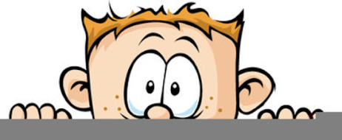

Peek at Our Week
Standard Focus | Activity | Home Extension Activity
- Identifies basic physical characteristics (e.g., landmarks or land features) | Using a world map and globe, discuss the continents and the oceans. Discuss why there was a need to invent boats to get from one land mass to another. Show how Florida is easy to identify on the map because it is a peninsula. | Children find maps very interesting. Draw a map of your neighborhood or how you drive to school. Make notes of landmarks along the way such as stores, ponds or cows in a field.
- Explores three-dimensional shapes in the environment through play | Building Boats  The children will use a variety of materials to make boats. 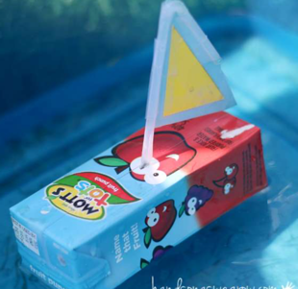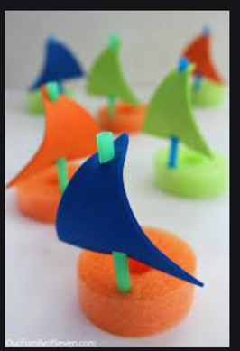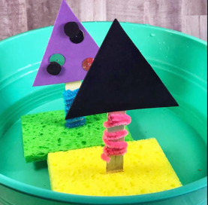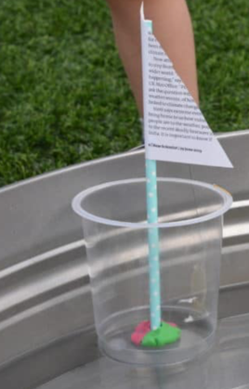 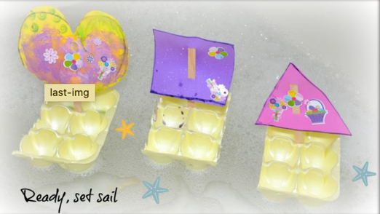 | Try making some boats at home. An egg carton, juice box, plastic cup, sponge or anything else that floats can be made into a boat. When making the boats talk about the shapes you are using. Then take them to the bathtub and test them out!
Parent Resources: Focus for the weeks is boats, triangles and rhombuses (diamonds).

