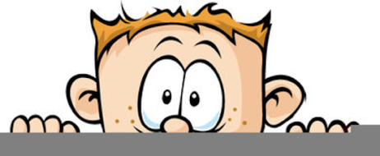

Peek at Our Week
Standard Focus | Activity | Home Extension Activity
- Uses increased vocabulary to describe objects, actions and events (expressive)  - Adds new words to vocabulary weekly (e.g., repeats words and integrates new words in play scenarios) (typically has a speaking vocabulary of approximately 1,000 words) | Discussion about which animals are good for transportation and why.  Record answers and post in classroom. | Continue this discussion at home by making a list of animals which could be used as transportation and ones that can’t. Write down your child’s responses and hang them up.
- Explores three-dimensional shapes in the environment through play | Making animals used for transportation out of playdough | Make some playdough at home using the recipe on the back of this paper. Use it to make animals with your child. Discuss the shapes used to make the animals and whether or not they could be used for transportation.
- Uses imagination and creativity to express self with intention using a variety of open-ended, process-oriented and diverse art materials  - Coordinates the use of hands and fingers  - Increasingly coordinates hand and eye movements to perform a variety of actions with increasing precision | Animal footprint stamping  The children will use our animal footprint stamps on a long piece of paper creating a mural. | Stamping is fun and so many items from around your house can be uses.  Food items such as carrots, potatoes, broccoli, or celery. Household items such as sponges, tin foil balls, cotton balls or cookie cutters. All you need is a little paint, paper, something to stamp with and some imagination!
Parent Resources: Focus for the weeks is animals as a form of transportation. We will also be discussing the following shapes: triangle, circle, oval and rectangle.

