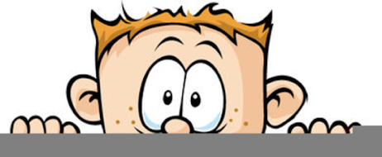

Peek at Our Week
Standard Focus | Activity | Home Extension Activity
- Uses increased vocabulary to describe objects, actions and events (expressive) | Explore our feet - count toes; compare toe sizes with other toes; learn terminology, heel, sole, ankle, arch, Achilles’ tendon, toenails, muscles, veins etc. Move foot around, stretch it in different directions and feel different muscles stretching | This week we are exploring using our feet as transportation. During this classroom, we closely examined our feet, pointing out all the different parts. This exercise increased their vocabulary and awareness of their body. You can continue this growth by point out different body parts to your child such as ribs, hips, spine and discussing their function.
- Coordinates the use of arms, hands, fingers to accomplish tasks with hand-eye coordination when participating in routines, play and activities | Sock matching and putting on and off | Children love socks. Give your child a pile of sock and not just their socks, mom’s, dad’s and siblings socks and let them explore. How many can they put on at once, can they sort by color, can they sort my size or owner, can they match the socks and put them away.
- Recognizes that print conveys meaning | Discuss why feet are not the best form of transportation. Record the children’s answers and hang up paper in classroom. | Continue the discussion of feet as transportation at home. Make a list of the pros and cons of feet as transportation and hang it up.
Parent Resources: For the next 8 week we will be learning about different forms of transportation, shapes and simple machines such as gears and ramps. This week’s focus will be on feet as the first form of transportation.

