Weekly Peek:
Week of: 4/4-4/8/22 Topics: Jesus Enters Jerusalem, Last Supper, Crucifixion. Teacher: Mrs. Danielle
Standard: | Activities: | Home Extension:
Fine Motor Development: Easily coordinates hand and eye movements to carry out tasks (e.g., working on puzzles or stringing beads together). | Students will be making necklaces or bracelets by stringing beads onto ribbon. | Create necklaces at home or complete another fine motor activity from the attached list.
Fine Motor Development: Uses coordinated movements to complete complex tasks (e.g., cuts along a line, pours or buttons, buckles/unbuckles, zips, snaps, laces shoes, fasten tabs.). | Last Supper craft: Students will tear brown and red pieces of paper into small pieces. Students will then glue the brown pieces of paper onto a picture of bread and the red pieces of paper on a cup to represent the Last Supper.  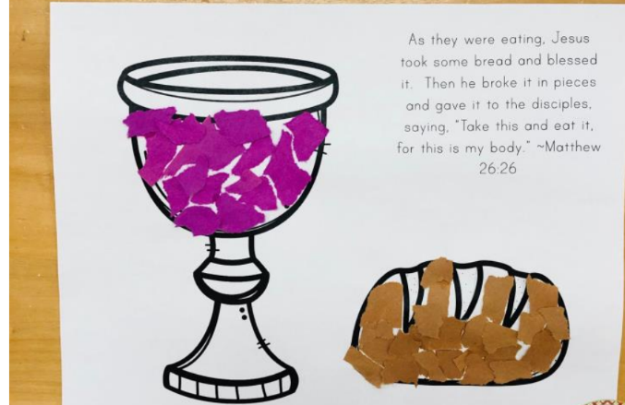 | Discuss the Last Supper
Language and Literacy: Increases knowledge through listening. | Students will listen to a variety of read-aloud stories and will discuss them to demonstrate knowledge gained. | Read stories aloud at bedtime and discuss them with your student.

