Weekly Peek:
Week of: 3/7/22-3/11/22 Topics: Jesus’ life Teacher: Mrs. Danielle
Standard: | Activities: | Home Extension:
Language and Literacy: Engages in multiple back-and-forth communicative interactions with adults (e.g., teacher-shared information, read-aloud books) and peers to set goals, follow rules, solve problems and share what is learned with others. | Read and discuss The Easter Story. | Read the student version of The Easter Story. Discuss why Jesus was arrested, why he died, and what does it meant that Jesus resurrected.  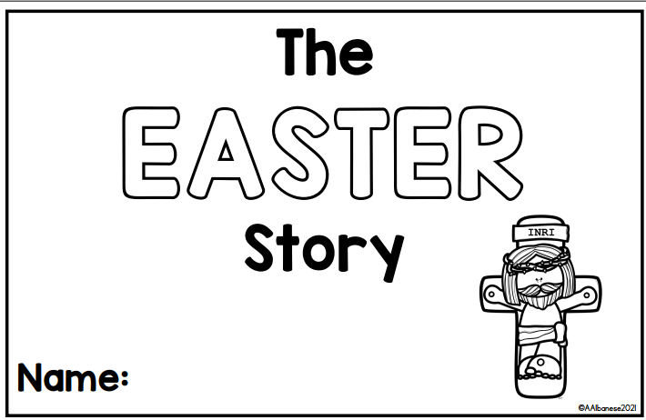
Language and Literacy: Combines words to make a compound word (e.g., “foot” + “ball”= “football”). | Students will work with the teacher to create compound words by completing compound word puzzles.  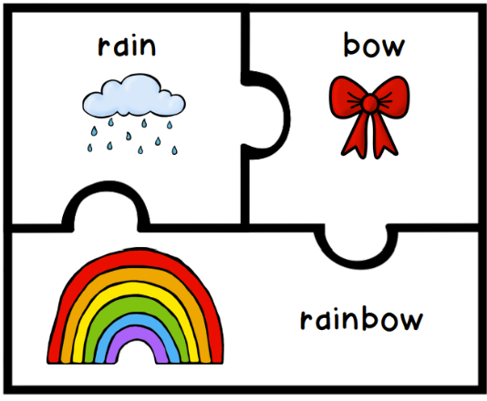 | Jack Hartmann compound words video: https://www.youtube.com/watch?v=a6Fyu2w2Pi8  Online compound word fish game: https://www.education.com/game/compound-word-fish/
Fine Motor Development: Demonstrates increasing precision, strength, coordination, and efficiency when using hand muscles for play and functional tasks. | Students will use yarn to lace and/or cross stitch a heart to represent God’s love for us. | Cut out various shapes, punch holes around the edge of the shape, and use yarn to create a design of your choosing.  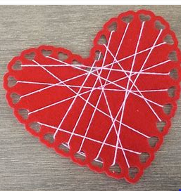  To work on fine motor development and hand strength, students can use clothespins, put beads on a string, or use tweezers to sort objects by color (for example, sort colored pom poms using tweezers).  