Weekly Peek:
Week of: 3/21-3/25/2022 Topics: Wedding at Cana, Jesus is baptized, miracles. Teacher: Mrs. Danielle
Standard: | Activities: | Home Extension:
Approaches to Learning: persistence: Attends to tasks for a brief period of time. | Students will create Resurrection gardens.  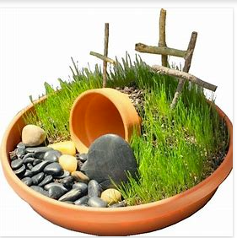 | Create your own version of the resurrection garden at home.  Discuss what the resurrection garden represents and why it is important to the Easter Story.
Engineering and Technology: Shows interest and understanding of how simple tools and machines assist with solving problems or creating objects and structures. | Block center: Welcome to Jerusalem:  We will discuss the time that Jesus went to Jerusalem on a donkey. Students will “build houses for the city of Jerusalem and a road, placing leaves and fabric pieces on the road.” Students can also use toy people and animals to act out the Easter Story. | Choose a Bible story. Discuss it as a family. Then, use toys and other materials to reenact the story to enrich understanding and connection.
Feeding and Nutrition: Recognizes nutritious food choices and healthy eating habits. | Students will sort pictures of food into healthy and nonhealthy food categories. | Plan your meals for the day (or week) and discuss which foods are healthy or unhealthy. If a food is unhealthy discuss why and what a better option may be.

