Weekly Peek:
Week of: 3/14/22- 3/18/22 Topics: What does Easter mean & Saint Patrick’s Day Mrs. Danielle
Standard: | Activities: | Home Extension:
Approaches to Learning: persistence: Attends to tasks for a brief period of time. | Students will create Resurrection gardens.  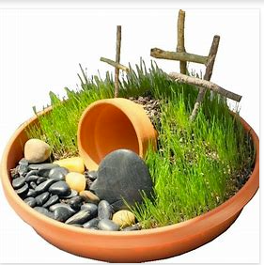 | Create your own version of the resurrection garden at home.  Discuss what the resurrection garden represents and why it is important to the Easter Story.
Social Studies: observes and recognizes changes that take place over time in the immediate environment. | Read, learn, and discuss about the history of Saint Patrick’s Day. Discuss how the celebrations of Saint Patrick’s Day have changed over time. | Discuss why we celebrate Saint Patrick’s Day.
Sensory Art Experience: Comines with intention a variety of open-ended, process-oriented and diverse art materials. | Create a visual representation of the three leaf clover, which is a symbol of Saint Patrick’s Day | Discuss how the three leaf clover is a physical representation of the Holy Trinity.

