Weekly Peek:
Week of: 2/28/22 Topics: Shrove Tuesday, Ash Wednesday, Lent, Sins, and WHY do we celebrate Easter. Teacher: Mrs. Danielle
Standard: | Activities: | Home Extension:
Creative Expression through the Arts: Sensory Art Experience:  Combines with intention a variety of open-ended, process-oriented, and diverse art materials | Students will create a Lenten Cross to help focus on keeping to their Lent goals each day.  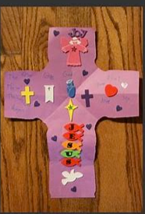 | Create a home version of the Lenten cross and say the weekly prayers each day as a family. Discuss the meaning behind Lent and the prayers.  A copy of Our Lenten Way of the Cross has been attached for your convenience.
Physical Development: Feeding and Nutrition:  Assist adults in preparing simple foods to serve to self or others. | Students will assist teachers in making pancakes for Shrove Tuesday. | Make pancaked from scratch and discuss the significance of eating pancakes on Shrove Tuesday.
Faith Formation:  Plays, works, and prays happily with others.  Develops a sense of awe and wonder, respect, gratitude and stewardship for God’s creation. | We will read: Footsteps to Jesus: A Lenten Journey for Children and discuss the importance of Lent.  We will discuss ways we can pray, do good work, and fast to be more like Jesus. | Read your student’s copy of the Lenten Journey story and discuss the importance of Lent. Plan goals to meet during Lent at home.
Resources:
Pancake recipe https://www.bettycrocker.com/recipes/classic-pancakes/77a89da1-fd56-494b-874a-55f9195c1413

