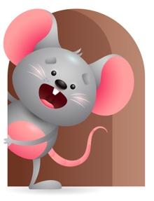
Peek at Our Week

Standard Focus | Activity | Home Extension Activity
Mathematical Thinking-Younger- Explores and experiments with objects and attends to events in the environment (shaking a rattle or ring of keys). Older- Measurement and data- Explores objects in various ways. | Younger- Explore the different toys by picking up and holding on to them and shaking to see if they do anything. Older- Explore different objects and see what you can do with them using your hands and fingers. | Younger & Older- Let them explore different objects to see how they work- do they roll? Bounce? Can you push them, does it make sounds? Does it move and then stop? Let them discover what they can do with it.
Language and Literacy-Younger- Increases knowledge through listening. Older-Demonstrates understanding when listening. | Younger- Read and sing the book Jesus Loves Me and talk about the things you see and what Jesus made for us and what he wants us to do. Older- Read the Story of Jesus and sing this little light of mine. | Younger & Older- I think it is important for us to read and sing to our children all through the day because they listen which means they are beginning to increase their knowledge and understand what you are saying. They just love singing. So, sing, sing, sing.
Social and Emotional-Younger- Managing Emotions. Older- Experiences and develops secure relationship with a primary caregiver. | Younger- Practice soothing their emotions -babies learn to calm down when you comfort them, sleep when you sing, relax when you rock them, smile when you play with them. Older- Interact while feeding or giving bottles and let them feel relaxed and secure. | Younger- Help them to manage their emotions- when they cry say what is wrong? Are you hungry? Need a bottle? Wet? Let us go and get a clean diaper. Tired? Need a nap? Older- always help them to feel secure and relaxed. Hold them when your giving a bottle, rock them to sleep, cuddle with them and sing.

Parent Resources

Other News-

