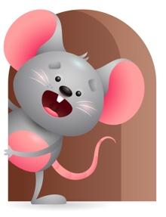
Peek at Our Week

Standard Focus | Activity | Home Extension Activity
Social Emotional-Younger- Managing Emotions- uses preferred adult to help soothe. Older- Building and maintaining relationships with adults and peers. | Younger- look in the mirror together and make faces with different emotions- happy- sad- crying- angry. Starts to realize how to get their needs met through crying to be changed-fed-or picked up. Older- Play little games like peek-a-boo- and sing where is (child’s name) I don’t know, we must go and find them. | Younger- make faces with emotions and tell them this is happy- sad- angry- tired- ask them how they feel today? Older- Interact with them and play with things they like. Build relationships with them- rock them to sleep or rub their back- cuddle and sing to them.
Physical Development- Younger- Motor Development- sits up to be able to reach for or hold objects. Older- Active Physical Play- engages in physical activities with increasing balance. | Younger- Play with Easter Eggs- show them how they come apart so you can fill them with objects-let them hold them in their hands to feel them -put them on the floor where they have to reach for them. Older- Using plastic eggs let them see how many they can put in a bucket and then dump it-see if they can balance one-pull one apart-or roll it across the floor. | Younger & Older- They love Easter Eggs- Let them explore them a little further by tasting them-give them a hard boiled egg to play with and tell them to taste it-let them watch you crack it and peel it. Make them scrambled eggs and have them try it. Let them help you color and decorate them. Have Fun!
Creative Expression-Younger & Older- Music & Creative Movement- responds to music in a variety of ways. | Younger & Older- Play musical instruments and move around the room- clap your hands-slap your knees-bounce up and down. Listen to the 4 CD’S in the My Build-a- Bible Story Books and move to the sound. Sing Jesus Loves Me- Rise and Shine- God made the World and Count your Blessings. | Younger & Older- Continue to have fun with music any way you can- Listen to it – Dance- Sing- Play instruments- Sing as you read a book.

Parent Resources

Other News- Have a Happy Easter!

