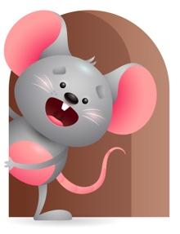
Peek at Our Week

Standard Focus | Activity | Home Extension Activity
Social Studies-Younger- Begins to explore characteristics of self (eyes, nose, hair). Older- Recognizes familiar people and objects. | Younger- Sing head-shoulders- knees and toes-eyes and ears and mouth and a nose-point to each part as you sing. Older- While playing with familiar objects they begin to recognize what they can do with them- blocks-stack or line up- balls-roll or bounce- fill and dump things- shake things to hear the sounds it makes. | Younger- talk to your child about body parts- point to each one and name them. They will learn them the more they hear them. Older- let them explore familiar objects to see what they do and how they sound and work.
Scientific Inquiry-Younger- Uses understanding of causal relationships to act on social and physical environments. Older- Displays interest in movement of objects. | Younger- Talk to them when you change them or feed them. Tell them what your doing and how you are doing it. Through play tell them what things are and show them how objects work. Older- Play with different objects-balls-cars- riding toys. Let them watch as they move across the floor. | Younger- Talk about the different things in their social and physical environment- Families, friends, siblings. Tell them how special each one is. Older- Let them explore objects that move- cars- riding toys- push toys.
Mathematical Thinking-Younger- Spatial Relations-explores the properties of objects and watches how they move. Older- Explores objects in various ways. | Younger- Tummy time- plays with balls- rattles – pop up toys. Watches what they do when you shake them -roll them- push the buttons. Older- Explore how many things you can do with an object- stack- roll-bounce-count-fill and dump- line up- knock them over. | Younger & Older- Continue to let them see how many things they can do with an object. Help them by showing them different ways to play with an object.

Parent Resources

Other News-

