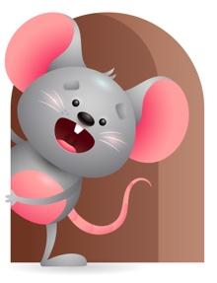
Peek at Our Week

Standard Focus | Activity | Home Extension Activity
Physical Development-Younger- Explores new body positions and movements-rolling over, sitting, crawling, hitting/kicking at objects. Older- Engages in physical activities with increasing balance, and coordination. | Younger- Tummy and floor time-practices crawling, rolling over from stomach to back, sitting with or without help, kicking at objects, and using muscles to raise their heads up. Older- While practicing position words- we will climb up and down slide, Crawl under the crib, go behind the chair, sit next to our friends. | Younger- Continue to help your child roll over, sit, crawl, raise their head. Put things in front of them that will encourage them to move and reach for. Older- Practice position words with them -do things that make you go in and out, up and down, on and off, outside, inside, over and under. Make a great learning experience out of it.
Social Studies-Younger- Begins to explore self- eyes, ears, nose, mouth. Older- Uses senses to solve problems. | Younger- Point to your body parts and name them and say what they do- eyes-see-nose-smells-mouth-taste-ears-hear. Older- while playing they start to see how things work- we will show them how plastic eggs come apart and how you can fill them with objects. Then we will see how many can fit in a bucket. | Younger- Continue to name body parts and say what they do. Repetition is the best way for them to learn. Sing head, shoulders, knees and toes-eyes and ears and mouth and nose-point to the part as you sing. Older- Help them to see how things work-balls bounce, cars roll, blocks stack and fall.
Scientific Inquiry-Younger- Notices cause and effect. Older- Uses senses to gain knowledge about objects. | Younger- Play with the pop- up toys and name the object that pops up and the sound it makes. Older- roll the cars across the floor and let them watch them go and then stop. | Younger & Older- Play and have fun and let them explore how objects sound, pop-up, move, spin, stop, stack, fall.

Parent Resources

Other News- We will continue to do our traditional prayers including the sign of the cross, daily and table prayers, listen to Bible Stories, recognizes that prayer is talking to God, and we will add knows that God loves, protects and provides for them.

