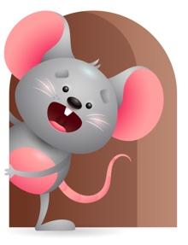
Peek at Our Week

Standard Focus | Activity | Home Extension Activity
Physical Development- Younger- Begins to use hands for play-reaching for and grasping toys. Older-Engages in physical activities with endurance and intensity. | Younger- while playing and reaching for easter eggs they try and grasp their hand and fingers around it and hold on to it. Older- Sing-Here comes Peter cottontail, and I’m a little Bunny. | Younger & Older- Sing some Easter songs and show them how to hop like a bunny, wiggle their nose, clap their hands, and just move all around and have fun with it.
Mathematical Thinking- Younger-Explores objects in hands. Older-Observes songs and finger plays that involve numbers and quantity. | Younger- Explores objects that are soft, hard, rough, sandy, silky, and bumpy. (blocks, balls, eggs, scarves, sandpaper). Older- Do songs. Line up plastic Easter eggs and count as you lay them down. | Younger-Give them different objects they can explore with their hands- blankets, dolls, cars, textured materials. Older- Give them a basket or small container and let them fill it up with objects-while they are picking up things and putting them in their basket count as they drop it in.
Approaches to Learning-Younger- Shows awareness of and interest in the environment. Older-Notices and shows interest in objects. | Younger-give them colorful eggs to explore and see all the things they can do with them-roll them, shake it, bounce it, use their senses to feel it, chew on it, listen to the sounds it makes. Older- Read Hop-along Bunny and Corduroy’s Easter-talk about all the things you see and what they are doing. | Younger- Look at Easter books with them and name the things you see. If you have touch and feel books, then let them feel each one. Tell them what it is and what it does. Older- Show them how to color eggs- Tell them you must cook them first- show them how you make the water turn different colors and how you dip them in-let them see how you crack them and let them have a bite to see if they like it.

Parent Resources

Other News- Sing some Easter songs. Have some special little treats.

