Peek at Our Week
Standard Focus | Activity | Home Extension Activity
- Shows an understanding of words and their meanings (receptive)  - Begins to demonstrate understanding of age-appropriate vocabulary across multiple topic areas and demonstrates a variety of words and their meanings within each area (e.g., world knowledge, names of body parts and feelings)  - Begins to understand the use of words in different context (including plurals and past tense in speech) | 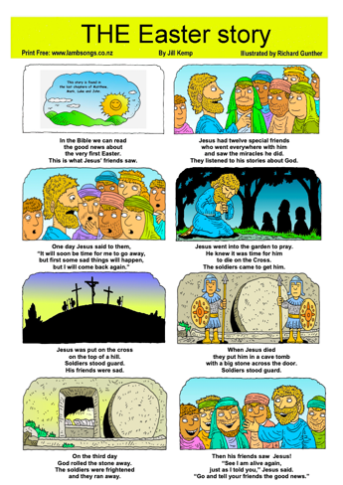  Easter Story Sequencing Cards | Use the attached laminated Easter Story sequencing cards at home to tell the Easter Story to your family.
- Begins to combine and coordinate two or more motor movements (e.g., runs with long strides showing arm and leg opposition; uses wheelchair to move in classroom) | Animal Walks  During outdoor play, we will practice different animals walks such as, crap, bear and kangaroo. | Turn this page over to see some examples of animal walks you can do at home with your child. Use your imagination and make-up some animal walks with your child.
- Recognizes characteristics of self as an individual  - Recognizes the ways self is similar to and different from peers and others | Easter Celebration | Come and participate in our Easter Celebration on Thursday April 14th in the Butterfly Garden.
Parent Resources: The Easter Story is the focus for this week.

