Peek at Our Week
Standard Focus | Activity | Home Extension Activity
- Uses senses to observe and experience objects and environment  - Uses tools in scientific inquiry | 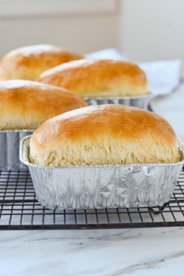  Make Bread in a Bag | The recipe for our Bread in a Bag is on the back. Have fun making it at home!
- Recognizes characteristics of self as an individual  - Recognizes the ways self is similar to and different from peers and others | Tasting breads from different cultures: Jesus came to save all people.  Talk about how Jesus and his disciples ate bread at the Last Supper. | Next time you’re at the grocery store, try buying a different type of bread such as a French croissant, a Jewish Challah bread, Naan bread from India, or Pita bread for Greece. Also, you could look up information about the country of origin for the bread.
- Notices a pattern with a missing object and completes the pattern by filling in the missing object | Easter Egg Patterns  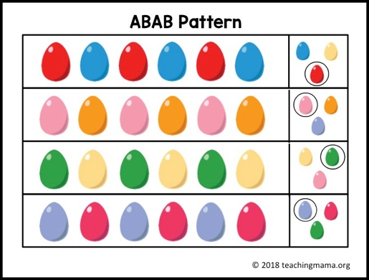 | You can incorporate pattern making into everyday activities. For example: have your child help you put the silverware away by handing them a spoon, then a fork and a spoon and then a fork; put the fruit in the refrigerator by handing your child an apple and then an orange and then an apple and then an orange and so forth.
Parent Resources: Jesus as the Bread of Life is the focus for this week. See the back side of this page for the Bread in a Bag recipe.

