Peek at Our Week
Standard Focus | Activity | Home Extension Activity
- Demonstrates increasing precision, strength, coordination and efficiency when using hand muscles for play and functional tasks | 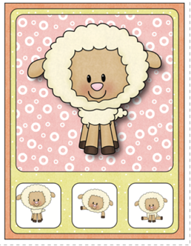  ”Which one is the Same?” Lamb Clip Cards | Clothes pins and chip clips are a great tool to use to build up fine motor strength. You can use them for color matching, counting activity, as a substitute for tweezers, and hanging up washcloths on a small clothesline.  Here is a link with some fun clothespin activities:  Pre-kpages.com
- Spends more time engaging in child-initiated activities and seeks and accepts help when encountering a problem | 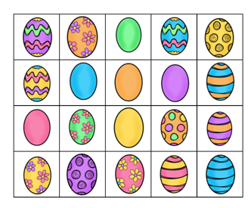  Easter Egg Matching Game | Matching and comparing sets/groups is an important math skill for preschooler. Sorting laundry and matching socks is not only a useful task for children to participate in, it is also a fun learning activity.
- Demonstrates use of large muscles to move in the environment  - Begins to combine and coordinate two or more motor movements (e.g., runs with long strides showing arm and leg opposition; uses wheelchair to move in classroom) | Herding Sheep  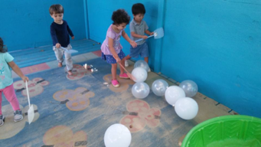 | Want to watch your child have fun while exercising their large muscles and increasing their eye-hand coordination, just give them some balloons and a large fly swat and have them herd the balloons into one small area of your yard or house. We are going to herd the “sheep” into the sandbox.
Parent Resources: Jesus as the Good Shepherd is the focus for this week.

