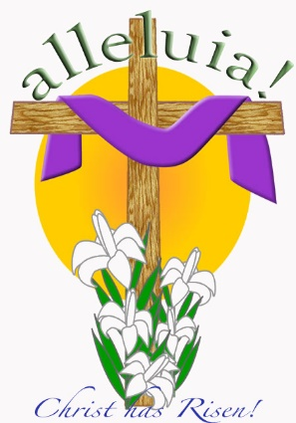
Standard | Activity | Home Extension
Standard 2 – Spiritual Development  SESD:2a – An appreciation of God’s goodness and personal love for them | Explain that Jesus overcame death, and that now that he died all of our sins can be forgiven, use the water with food coloring and bleach demonstration. | Talk about how God made them perfect and unique! Remind them that God loves them and that he loves them just like you do!
VII Social Studies  D. Spaces, Places, and Environment (2) - Explores own environment | We will talk about the empty tomb, and we know he’s alive because he’s not there anymore. | The park is a great time to be on the lookout for what's around. As you walk with your child, point out groups of birds, trees, leaves, people, etc. and ask him/her, "How many do you see?" Take turns pointing to different things all over the park!
III Social and Emotional Development  Emotional Functioning (1) Expresses, identifies and responds to a range of emotions. | Use a 2 sided cross to discuss how somethings about Jesus dying are happy, and how some are sad. | Look at the characters faces when you are reading a story or watching a show with them. Discuss how you think they are feeling. If they are having trouble identifying it help them out. Start asking if they can make a “sad” face or “happy” face.

