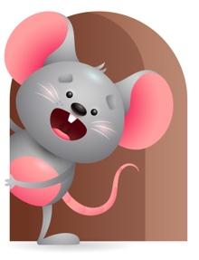
Peek at Our Week

Standard Focus | Activity | Home Extension Activity
Mathematical Thinking-Younger-Explores objects in various ways-watches how they move and work. Older-Explores objects with different characteristics. | Younger- Explores objects by mouthing, touching, shaking, dropping , banging, and rolling. Introduce pop beads and talk to them about the colors they are. Older- Play with shape sorter and name the color and shape they are as you put them in the right place in the bucket. | Younger & Older- Let them explore things by using their senses to taste, touch, smell. Hear. They can shake, mouth, touch, bang, drop, or roll it. Let them see how it works and moves. Talk about the characteristics it has- hard, soft, round, square.
Creative Expression- Younger- Creative Movement- Uses movement to show body awareness in response to own environment. Older- Appreciation of the Arts- Responds to different forms of art. | Younger- Play Music as they clap their hands, kick their legs, and bounce up and down to the sound of the music. Older- Paint on egg cartons, boxes, sandpaper, let them use their fingers to smear green paint. | Younger- play music and encourage your child to move their bodies- bounce, rock back and forth, kick their legs, clap hands. Older- Continue to let them paint on different objects – boxes, paper, foam, high chair lid. Make sure you talk about the color their using.
Scientific Inquiry-Younger & Older-Uses senses to explore and understand their social and physical environment. | Younger & Older- We will use our senses to explore their physical environment- Eyes to see how things look and work, ears to hear how things sound, nose to smell different things, and mouth to taste different green colored foods. | Younger & Older- Continue at home with letting them explore their senses and enjoy tasting different colored foods. It will help them to eat well if they have a colorful looking plate and a variety. We are doing green this week so try some green foods.

Parent Resources

Other News-

