Peek at Our Week
Standard Focus | Activity | Home Extension Activity
- Demonstrates directionality, order and position of objects by following simple directions  - Responds to and expresses opinions and feelings about own art form as well as a variety of artistic expressions of others | 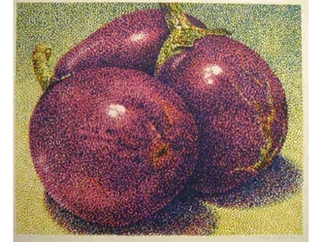  Jerry Wilkerson’s eggplants (pointillism)  The children will paint using a nail brush to create the fine dot effect used in pointillism. | Children love to paint with all types of objects. Our home is filled with interesting items to paint with. Here are a few examples: toothbrushes, crumbled up tin foil, string, sponges, sliced fruits of vegetables, Q-tips, cotton balls, forks, potato masher, and so many more.
- Makes simple predictions and reflects on what caused something to happen  - Participates in and discusses simple experiments  - Responds to and expresses opinions and feelings about own art form as well as a variety of artistic expressions of others | Watercolor paint on a coffee filer with red and blue paint to create purple | Coffee filter papers are fun to paint on because the paint spreads out. Give your child a coffee filter which is set on a cookie sheet. If you don’t have watercolor paints, just add a few drops of food coloring to water or use bath color tabs. Q-tips, as the brush, work great for this project.
- Describes what objects are used for and is able to express ideas (e.g., names some colors, shapes, and says full name) | Arrange paint chips from light to dark shade | During this unit, the children have been introduced to the concepts or hue, tint and shade. Give your child a small amount of a primary or secondary color paint and some white and black paint. Let them experiment making lighter tints and darker shades of the original hue.
Parent Resources: The color of the week is purple. The children will be learning that mixing red and blue results in purple.

