Peek at Our Week
Standard Focus | Activity | Home Extension Activity
- Participates in and discusses simple experiments  - Responds to and expresses opinions and feelings about own art form as well as a variety of artistic expressions of others | Damien Hirst Spin Paintings.  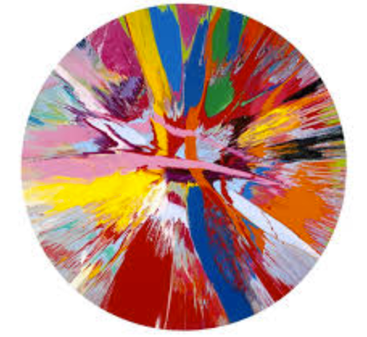  The children will use a salad spinner to make a spin painting using yellow, red and orange paint. | If you have a salad spinner, get some paint and a coffee filter or paper cut into a circle and spin way. I suggest adding some water to your paint to thin is down a bit. Also use lighter colors. If you don’t have a spinner, put some large dots of paint on the back of a paper plate and flip it over onto a piece of paper. Press down on the plate and give it a turn. Lift the plate to see your masterpiece!
- Begins to recognize nutritious food choices and healthy eating habits  - Participates in group sorting and data collection  - Describes what objects are used for and is able to express ideas (e.g., names some colors, shapes, and says full name) | Sort pictures of fruit and vegetables into color categories | Cut pictures of fruits and vegetables out of grocery circulars or magazines then glue them onto corresponding colored paper.
- Increasingly coordinates hand and eye movements to perform a variety of actions with increasing precision  - Sustains attention for brief periods and finds help when needed | Throwing rings around colored cones. Tossing balls and bean bags into colored buckets and cups. | Cognitive skills are be practiced outside also. You could throw different colored balls into a bucket while shouting the name of the colors. You could instruct your child to run to the blue piece of paper and then the red one. The possibilities are endless!
Parent Resources: The color for the week is orange. The children will be discovering that mixing yellow and red created orange.

