Peek at Our Week
Standard Focus | Activity | Home Extension Activity
- Represents ideas and observations through drawings or using other forms of representation (e.g., manipulatives or different objects) | Michelangelo’s Sistine Chapel  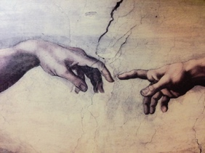  The children will experience what it is like to paint on the “ceiling”. A piece of paper will be taped to the bottom of a table and the children will paint on it with different shades of white. | Performing a task from a different position can help a child develop a better sense of their body in space. For example: try putting your socks on while laying on your back with your feet in the air or try putting a puzzle together on the floor while laying across a foot stool with your arms and head hanging down.
- Participates in group sorting and data collection  - Describes what objects are used for and is able to express ideas (e.g., names some colors, shapes, and says full name) | Sort nature pictures by color | Take some time this week to notice the colors in nature. Take a walk around your yard and see how many different colors you can find. When cooking and eating dinner, discuss the colors of the foods.
- Expresses, identifies and responds to a range of emotions  - Identifies complex emotions in a book, picture or on a person’s face (e.g., frustrated, confused) | 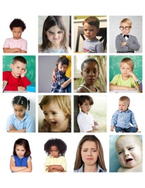  Read the Color Monsters and then sort emotion pictures into categories. | When reading books to your child this week focus on the emotions the characters are feeling. Ask your child what the character is feeling, how they know what the character is feeling, and why is the character displaying this emotion.
Parent Resources: For the next 8 weeks, we will be learning about and exploring colors. The children will be introduced to a painting from a famous artist and then given a chance to recreate the painting using different techniques. This week’s color is white.

