Standard | Activity | Home Extension
I Physical Development  B. MOTOR DEVELOPMENT  c. Motor Development  1. Demonstrates increasing precision, strength, coordination and efficiency when using hand muscles for play and functional tasks | Children will use tweezers to sort different colored poms into ice cube trays.  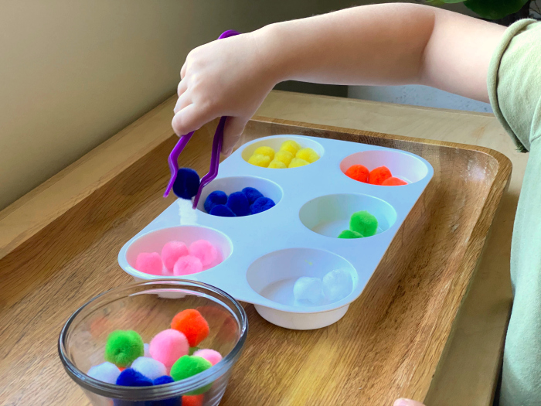 | Encourage children to flip make-believe pancakes with a small spatula, skillet and sponge. The adult cuts the edges of the sponge to create a pancake shape. Demonstrate for children how to flip the pancake and then feed it to one of their stuffed animals.
II Approaches to Learning  C. CREATIVITY AND INTUITIVENESS  1. Explores the environment with purpose and flexibility | Ask children who, what or why questions during play, and use these times as a chance to have conversations.  Provide different toys that can be used in many ways and allow the children to explore them. | Provide a bit of support when children try to finish new things while being careful not to take over completely.  Encourage children to ask questions, try different ways of using materials or offer them a wide range of new experiences.
III Social and Emotional Development  C. BUILDING AND MAINTAINING RELATIONSHIPS WITH ADULTS AND PEERS  2. Develops positive relationships with peers.  Benchmark a.  Seeks out other children and plays alongside and on occasion with other children | Facilitate activities where the children play together. i.e., kick a soccer ball back and forth, build a tower together, etc.  Model how to play with another child. | Encourage play dates outside of the home where they can interact with other children.

