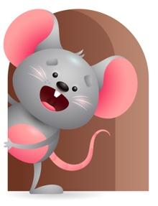
Peek at Our Week

Standard Focus | Activity | Home Extension Activity
Scientific Inquiry-Younger- Begins to use senses and a variety of actions to explore people and objects in the world around them.( mouthing, touching, shaking, dropping).Older-r-Demonstrates knowledge related to living things and their environment. | Younger- Let them explore the blocks with their senses and see what sound it makes when you shake it, or drop it. How does it feel when you touch it? (Hard, soft, or squishy). Older- Talk to them about living things like dogs, cats, birds. Show them pictures of them and tell them what each one does. | Younger- Let them explore different things with their senses-materials, food, toys, people. Older-Talk to them about different animals and tell them what they are and where they live-including the ones that might live at their house.
Approaches to Learning-Younger- Eagerness and Curiosity. Older- Attends to sights, sounds and people for brief and increasing periods of time. | Younger While playing they get curios and eager to see what something does so they go explore it so they can see what happens. Play pop up toys and musical toys. Older- Listens to teacher as she sings Christmas songs and joins in with musical instruments.( bells, drums, piano). Sing Jingle Bells, and Rudolph the red nose reindeer. | Younger-They are so eager to get in to things -let them see how things work at home. ( a pull toy, a push toy, swing, wagon). Older- Sing to them and do movements for them to watch the more you do it they begin to get pleasurably movements from it and enjoy it.
Creative expression-Younger- Music-responds to music in a variety of ways. Older-Responds spontaneously to different forms of art in the environment. | Younger- Play music- 17 play songs and let them just move to the beat-do some moves and see if they copy you. Older- Finger paint with a variety of colors- use markers and crayons too. | Younger- Play music and dance around with your child-do some moves and show them things they can do with the beat they hear-wiggle, bounce, shake, clap hands. Older- Give them crayons and markers and let them scribble on paper or boxes.

Parent Resources

Other News-

