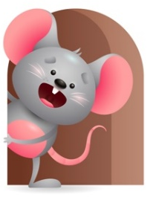
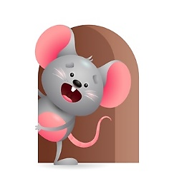
Peek of the Week

Standard Focus | Activity | Home Extension Activity
Scientific Inquiry-Younger- Uses senses to explore and understand their physical environment. Older-Shows curiosity about own body structure (two legs, fingers for grasping). | Younger- explore people and objects with your senses (touching, mouthing, shaking, looking). Older-Practice using legs to stand and walk, hands to pull up on things, knees to crawl, fingers to hold things, | Younger- Give them things they can explore their senses through ( taste foods, feel cold objects, touch different textures). Older- Continue to let them explore what their body can do. ( grasp toys, pull up, stand, walk, crawl, clap hands, kick objects).
Creative Expression-Younger- Responds to music in a variety of ways. Older-Uses movement to show increasing body awareness. | Younger- Play music- Baby’s First Christmas songs-let them move to the sounds. Bounce up and down, clap your hands, wiggle all around, stomp your feet, Shake yourself. Older- Play Christmas music and give them some instruments to play and let them just move. Do some motions and see if they copy you. | Younger and Older- Continue to play Christmas music and let them just move and use their body parts- Legs, hands, fingers, feet. Let them bounce up and down, shake, clap hands ,wiggle all around, give them objects they can use for instruments-bells, pots and pans, spoons to pound with, rattles, Dance with your child. Have fun with it.
Physical Development-Younger- Uses new ways to learn to explore the environment. Older- Engages in physical activities with increasing balance and coordination. | Younger- Practice lying on floor and holding head up for a while and reaching for objects. Older- Practice pulling up, standing, walking with or without push toy. | Younger- Continue to let them practice rolling from tummy to back, raising head, sitting with or without help. Place toys on floor so it will encourage them to reach for them. Older- Give them push toys they can walk with to practice.

Parent Resources

Other News-

