Peek at Our Week
Standard Focus | Activity | Home Extension Activity
- Begins to explore a greater variety of motions with objects (e.g., rotate, spin, twist) | String Bells on Pipe Cleaner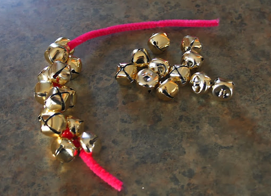 | Christmas time is a great time to string items. String beads or bells for your tree or as a garland.
- Demonstrates use of large muscles for movement, position, strength and coordination | Play “Packing and Pushing/Pulling Santa’s Sled”  Fill Santa’s sled with presents and push it around the playground. (blue wagon with blocks) | Heavy work is important for the development of your child’s large muscles. I have printed a list of “heavy work” activities for your child to do at home.
- Explores the environment with purpose and flexibility  - Demonstrates knowledge related to physical science | 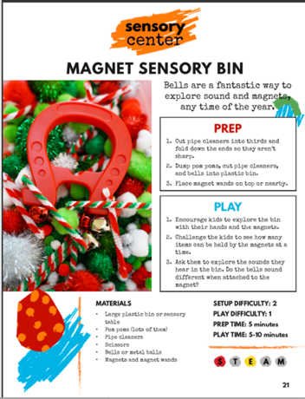 | 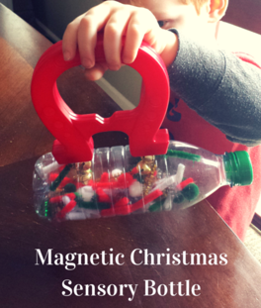  If you didn’t get a chance to make the magnetic sensory bottle, I suggested a few weeks ago, now’s your chance.  Magnets are so much fun for children to use to explore their world. Put jingle bells (Available at the Dollar Tree) and small pieces of pipe cleaner and put them in an empty plastic bottle. Run a magnet up the side of the bottle to catch the jingle bells.
Parent Resources: Heavy work handout attached.

