Peek at Our Week
Standard Focus | Activity | Home Extension Activity
- Begins to explore a greater variety of motions with objects (e.g., rotate, spin, twist)  - Demonstrates ability to self-regulate | MagnaTile Christmas Tree Activity  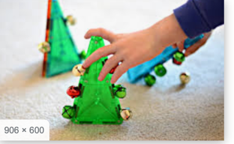 | 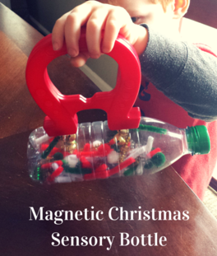  Magnets are so much fun for children to use to explore their world. Put jingle bells (Available at the Dollar Tree) and small pieces of pipe cleaner and put them in an empty plastic bottle. Run a magnet up the side of the bottle to catch the jingle bells.
- Manipulates objects by flipping, sliding and rotating to make them fit | Christmas Puzzles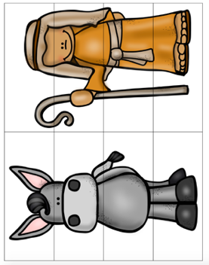 | This type of puzzle is very easy to make just a magazine or photograph into simple pieces and have your child assemble it.
- Counts and identifies the number sequence “1 to 10” | Roll and Build Nativity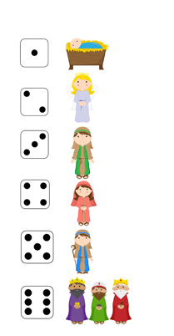 | Dice can be used to make clean-up fun! Have your child roll the dice and then pick up that many toys. Using a wooden cube or a plastic photo cube, you could make your own dice with colors, shapes, types of toys or clothes.
Parent Resources:

