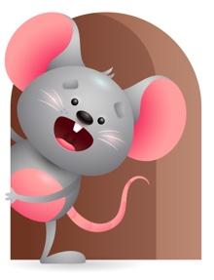
Peek at Our Week

Standard Focus | Activity | Home Extension Activity
Language & Literacy-Younger- Increases knowledge through listening. Older- Listening and understanding. | Younger- Read the flap book-Where is baby’s belly button. Talk about the different body parts and what they do. Older- Read and look at the book- My Favorite Pets-touch and feel each animal and make their sound. | Younger- Continue to read different books and tell them what is happening in the picture or tell them what it is and what it does. Older- Touch and feel different objects and tell them what it is and what it does.
Social & Emotional- Younger- Develops positive relationships with peers. Older-Develops positive relationships with adults. | Younger- While interacting together we will look, touch, and listen to the sounds that objects make. Older- While interacting together we will play a game using their name and say Who touched the book? Who dropped the block? How does that feel? (soft, hard, scratchy). | Younger- Continue to interact with them through play and help them to have a positive outcome. Let siblings and friends join in. Older- Play with them and help them to have positive relationships with older siblings and adults.
Approaches to Learning-Younger- Eagerness & Curiosity. Older-Creativity & inventiveness. | Younger- Listen to all the sounds you hear around the room. Older- Put different objects out and let them explore through their senses. | Younger- they are curious so give them a variety of things to explore. Older- They have excitement for familiar objects so give them things they know how to use.

Parent Resources

Other News-

