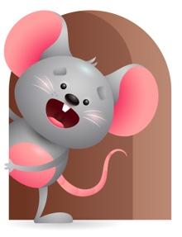
Peek at Our Week

Standard Focus | Activity | Home Extension Activity
Creative Expression-Younger- Creative Movement. Older-Sensory Art Experience. | Younger-We will have tummy time and practice reaching for toys. Older- We will paint with brushes and fingers and see what we come out with. | Younger- Put toys out of their reach so they will have to move to get them. Older- Try letting them finger paint and feel the paint between their fingers.
Scientific Inquiry-Younger- Uses senses to explore and understand their social and physical environment. Older- Shows curiosity about body structure. (two legs, fingers). | Younger-While having tummy time they will explore through their senses in a variety of ways. (mouthing, touching, listening). Older- Play a game naming body parts and what they do? (Eyes to see, nose to smell, ears to hear). | Younger- Continue to give them things they can explore through their senses. (toys, textured materials, different foods). Older- Practice showing them fingers are for eating, feet are for walking, knees are for crawling.
Social Studies-Younger- Begins to respond to schedule. Older-Individuals and groups. Recognizes family members, people, and objects. | Younger- Have play time, snack and bottles, lunch, and nap at the same time every day to help them respond to schedules. Older- Using puppets in group or individual ask questions like where are your eyes? Feet? Hands? Belly? | Younger- Try to keep your same schedule at home so they will respond to it. Older- Talk about family members and people and let them know who each one is.

Parent Resources

Other News-

