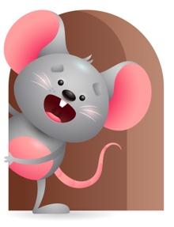
Peek at Our Week

Standard Focus | Activity | Home Extension Activity
Mathematical Thinking-Younger- Explores the properties of objects and watches how they move. Older- Explores objects with different characteristics. (patterns). | Younger- We will explore objects in the environment and see how they move and listen to the sound they make. Older- We will show them patterns like circle, square, triangle, and show them on the shape sorter bucket where they go. | Younger- Show them different objects and let them see how they move and what sounds they make. Older- Let them play with different patterns.
Scientific Inquiry- Younger- begins to use senses and a variety of actions to explore people and objects in the world around them. (mouthing, touching, shaking, dropping). Older- Uses senses to gain knowledge about objects. | Younger- Put different textured objects out for them to explore with their senses. Rough-soft- cold- fuzzy. Older- Give them things that have wheels, spins, and pops up, so they can explore how they work. | Younger- Continue to let them explore different objects with their senses- sandy, smooth- scratchy, soft. Older- Continue to give them things that they have to figure out with their senses how it works.
Creative Expression-Younger- Creative Movement. Older- Appreciation of the Arts. | Younger- Play games- Pat-a-cake, this little Piggy, Clap, Clap, Clap your hands. Older- Place an object in a jar -add paint and shake it up. | Younger- Do things that require movement- finger plays, exercise their legs for them, dance and shake your body. Older- Be creative- paint, roll paper balls, tear paper, build with blocks.

Parent Resources

Other News-

