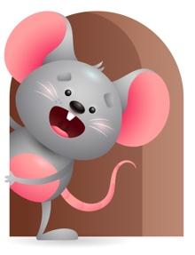
Peek at Our Week

Standard Focus | Activity | Home Extension Activity
Language and Literacy- Younger- Reacts to environmental sounds and verbal communication. Older-Responds to gestures of adults. | Younger- Read the book -Look who’s mooing with 10 other sounds to hear. Say each sound and then name the animal. Older- Read the book- Never touch a monster and point and touch each of the different textures- and tell them to do it. | Younger- Let them hear different sounds and tell them what it is. Music playing, doorbell ringing, people talking, dogs barking. Older- Touch and feel objects and tell them to touch it. Blankets, splash in the water, hold a phone to your ear.
Social Studies-Younger-Begins to respond to schedules. Older-Individual Development and identity. | Younger- Starts to respond to drop off time and pick up at the end of the day, feeding time, nap time, floor time, and outside time. Older- Sing head, shoulders, knees, and toes, and point to each part. | Younger- Continue to do things at the same time each day- eat, sleep, play. Older- Play a game where is your nose? Eyes? Ears? Point to each part and name them.
Physical Development- Younger- Demonstrates increasing strength when using hand muscles for play. Older- Demonstrates increasing interest in eating habits. | Younger- Practice holding on to toys and shaking and squeezing them without dropping them. Older- Give a variety of fruits and vegetables for them to pick up and eat. | Younger- Let them hold their own bottles and toys. Let them practice holding on to you while standing. Older- Give them a variety of finger foods to enjoy and make choices of what they like.

Parent Resources

Other News-

