Peek at Our Week
Standard Focus | Activity | Home Extension Activity
IV. LANGUAGE AND LITERACY  F. EMERGENT READING  3. Shows alphabetic and print knowledge  IV. F. 3. a. Recognizes that print conveys meaning | 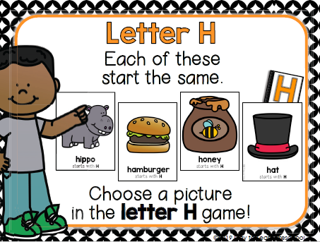  Our letter this week is "Hh" | 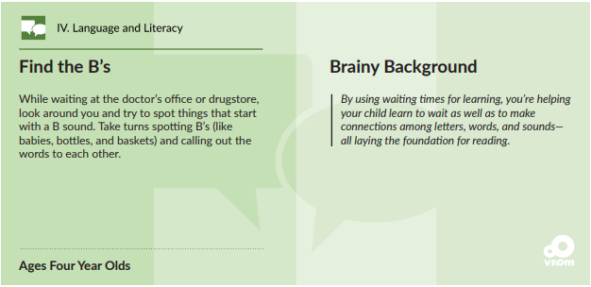  Find the H’s [Just as this activity describes, you can look for Letter H.]
A. SCIENTIFIC INQUIRY  1. Uses senses to explore and understand their social and physical environment  VI. A. 1. a. Identifies each of the five senses and the relationship to each of the sense organs | 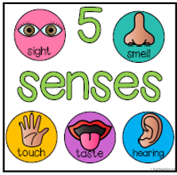 | 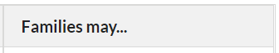  Florida Office of Early Learning:  Provide opportunities to use sense of touch to experience how things feel (warm, cold).
V. MATHEMATICAL THINKING  F. MEASUREMENT AND DATA  V. F. 2. Identifies measurable attributes (such as length and weight and solves problems by making direct comparisons of objects) | 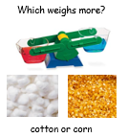  Weighing and compairing cotton balls and corn. | Florida Office of Early Learning:  If near water (e.g., a pond, river or the sea), skip rocks into the water, talking back and forth about how differences in the shapes and sizes of the rocks affect how they skip. If near a big puddle, families can do a similar experiment with rocks, sticks or leaves.
FAITH FORMATION  Faith Development Concepts  SAFE ENVIRONMENT STANDARDS  Standard 1 -Cognitive Development  SECD:1d There are “good’ and “bad” choices | Adam and Eve being cast from the Garden of Eden Genesis 2-3  Noah’s Ark Genesis 6-9  Sodom and Gomorra Genesis 19 | Read and discuss these Old Testament stories using a children’s picture bible.

Parent Resources:
Other News: This week we begin a new unit. We will explore many aspects of fall as we learn about our 5 senses.
Last week we sent home the “Nancy Daniels” fundraising catalogs. You, your friends and family can also order items online. (Christmas is 12 Weeks Away!) Thank you for helping SHECC with this fundraiser!!

