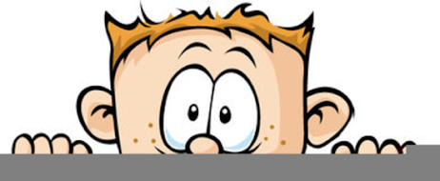

Peek at Our Week
Standard Focus | Activity | Home Extension Activity
- Recognizes a simple AB pattern  - Uses senses to explore and understand their social and physical environment | 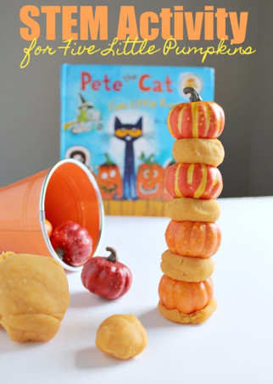 | This activity uses playdough as glue to hold the pumpkins together. Try giving your child some craft sticks and some playdough and see what they can create. See if they can make a tunnel or bridge. Can they make a table strong enough to hold a small car or other toy?
- Explores own environment  - Recognizes a simple AB pattern | 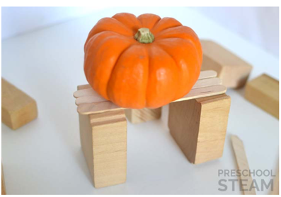
- Develops independence through coordinated and purposeful movements and activities  - Demonstrates awareness of own body in space | The children will be encouraged to engage in activities which help them become aware of own body in space such as spinning in the teacup, hanging from the monkey bars, climbing on the rainbow climber, using the balance beam, and swinging on the belly swing. | Other vestibular activities which can be done at home are jumping on a trampoline, yoga, rocking in a hammock, swinging, spinning in a swivel chair, somersaults and rolling or bouncing on a ball.
Parent Resources: For some fun and easy patterning activities, see The Measured Mom.

