Peek at Our Week
Standard Focus | Activity | Home Extension Activity
- Begins to use senses to observe and experience the environment  - Uses senses to explore and understand their social and physical environment | Touch bag game:  Place items in a bag and have the children put their hand in and identify the object just using their sense of touch. | Make a touch bags at home using a pillowcase and items around your house. Take turn putting your hand in the bag and guessing what you chose.
- Begins to use senses to observe and experience the environment  - Uses senses to explore and understand their social and physical environment | While eating apples slices, apple chips, dried apples and apple sauce concentrate on feeling and describing the different textures of each item. Record the children’s responses and hang in room. | You could do a similar activity using potatoes. Eat mashed potatoes, French fries and potato chips. Talk about how each item is made from potatoes but looks and feels different.
- Uses senses to explore and understand their social and physical environment  - Begins to use senses to observe and experience the environment  - Uses imagination and creativity to express self through open-ended, diverse and process-oriented art experiences with intention | 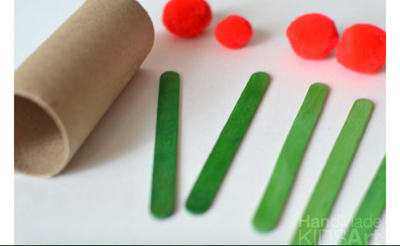  The children will be given the pictured items and asked to build an apple tree. | Why not take a walk in your yard and collect sticks, leaves, acorns, etc. and use them to make an apple tree. You could glue them on a piece of paper or just try to balance them.
Parent Resources: Our focus this week is touch.

