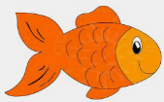
Peek at Our Week
Standard Focus | Activity | Home Extension Activity
IV. LANGUAGE AND LITERACY  F. EMERGENT READING  2. Shows age-appropriate phonological awareness  3. Shows alphabetic and print knowledge  IV. F. 3. a. Recognizes that print conveys meaning | Our letter this week is "Dd"  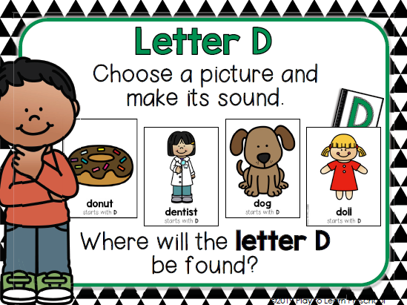 | 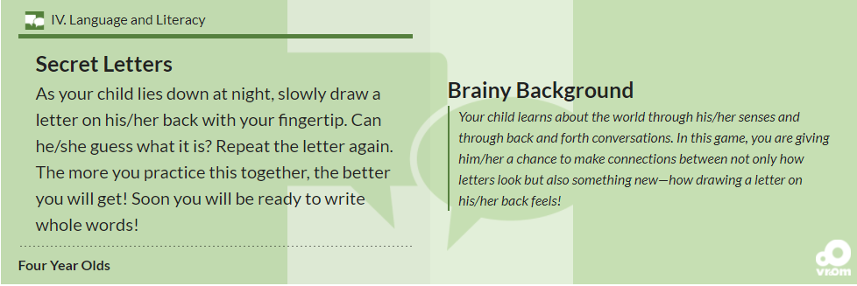
FAITH FORMATION  Plays, works and prays happily with others.  Develops a sense of awe and wonder, respect, gratitude and stewardship for God’s creation. | 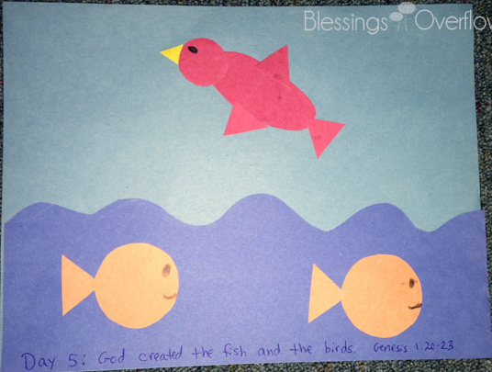  God created the fish and the birds. Genesis 1:20-23 | Read, look at pictures, and discuss “Creation” in a children’s picture Bible.  Read books about plants and animals and their characteristics.
V. MATHEMATICAL THINKING  V. A. 5. Constructs and counts sets of 0-10 objects  V. A. 7. Reads and writes some numerals using appropriate activities | 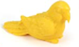  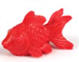  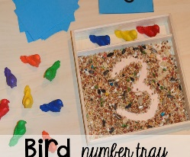 | Ask for children’s help in distributing items like snacks, or in laying napkins out on the dinner table (e.g., one napkin per plate).

Parent Resources: "Literacy Home Extension Activity" taken from this website: http://www.floel.org/standardsresource/details.html#p=resources/IV/four_year_olds/F/3/Benchmark%20b&d=IV,V&a=four_year_olds

Other News: Thank you to those who have brought in a shoe box or shoe box size plastic container. They are helping contain and separate the students’ water bottles, shoes, etc.

