Peek at Our Week
Standard Focus | Activity | Home Extension Activity
IV. LANGUAGE AND LITERACY  F. EMERGENT READING  3. Shows alphabetic and print knowledge  IV. F. 3. a. Recognizes that print conveys meaning  C. VOCABULARY  2. Uses increased vocabulary to describe objects, actions and events (expressive)  IV. C. 2. a. Uses a large speaking vocabulary, adding new words weekly (e.g., repeats words and uses them appropriately in context) (typically has a vocabulary of more than 1,500 words) | Our letter this week is "Ff"  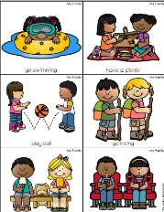  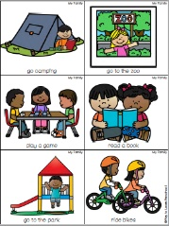  The children will share what kinds of activities they like to do with their families | 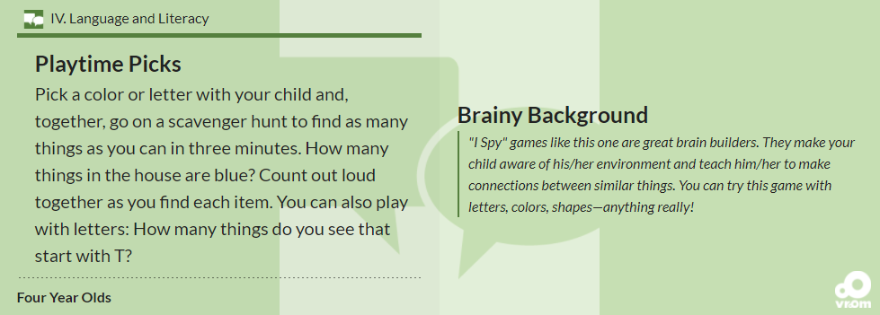  Florida Office of Early Learning shares an idea to help your child increase expressive vocabulary
FAITH FORMATION  Recognizes that prayer is talking to God.  SAFE ENVIRONMENT STANDARDS  Standard 2- Spiritual Development  SESD:2e A sense that God loves all individuals and gives us families composed of members who help each other | Creation: Day 7  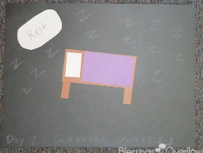  God rested. (Genesis 2:2-3) | Read, look at pictures, and discuss “Creation” in a children’s picture Bible.  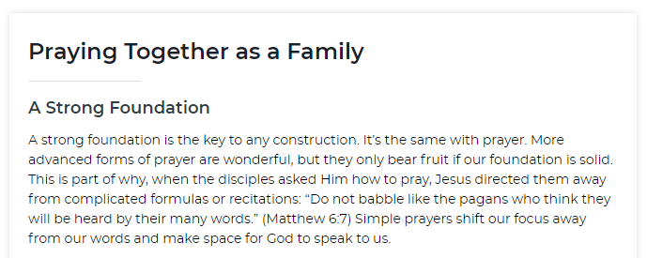
V. MATHEMATICAL THINKING  V. MATHEMATICAL THINKING  A. NUMBER SENSE  V. A. 6. Uses counting and matching strategies to find which is more, less than or equal to 10 | 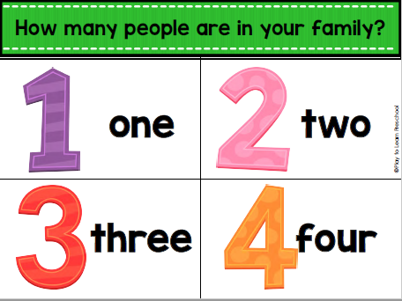  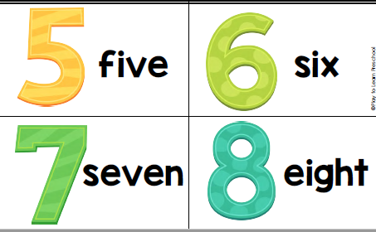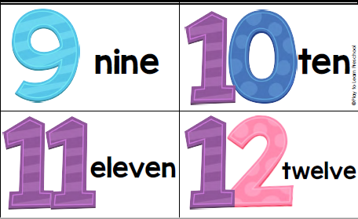 | Count the number of people in different families you know. Compare the numbers--more than, less than.

Parent Resources: Praying Together as a Family: https://marriagefamilylife.seattlearchdiocese.org/prayer

Other News: If you would like to share a family picture with our class and you have not already, please see Ms. Karen for ways to share your picture.

