Peek at Our Week
Standard Focus | Activity | Home Extension Activity
IV. LANGUAGE AND LITERACY  F. EMERGENT READING  2. Shows age-appropriate phonological awareness-Listens and matches rhythm, volume and pitch of rhymes, songs and chants  3. Shows alphabetic and print knowledge  IV. F. 3. a. Recognizes that print conveys meaning | Our letter this week is "Ee"  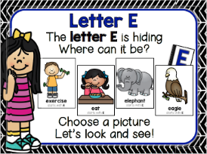  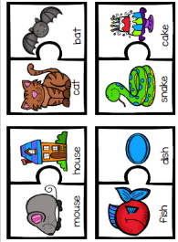  Rhyming Words | 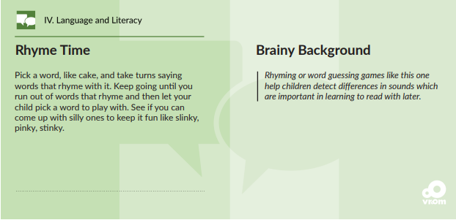
FAITH FORMATION  Plays, works and prays happily with others.  Develops a sense of awe and wonder, respect, gratitude and stewardship for God’s creation.  VI. SCIENTIFIC INQUIRY  B. LIFE SCIENCE  1. Demonstrates knowledge related to living things and their environments  VI. B. 1. a. Identifies characteristics of a variety of plants and animals including physical attributes and behaviors | 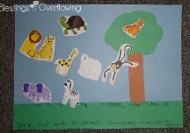  God made the animals.  Genesis 1:27-31  We will learn about animals, and some of the characteristics of animals. We will talk about which animals are wild and which can be pets. | Read, look at pictures, and discuss “Creation” in a children’s picture Bible.  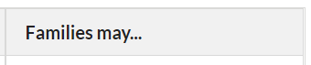Read books about animal adaptions or animal homes/habitats (e.g., animals living in different places have special features that help them to survive). [From Florida-Office of Early Learning]
V. MATHEMATICAL THINKING  V. A. 5. Constructs and counts sets of 0-10 objects  D. GEOMETRY  V. D. 1. Recognizes and names two-dimensional shapes (circle, square, triangle and rectangle) of different size and orientation | Count 6 objects; Sorting  arrange and count Shapes  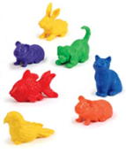  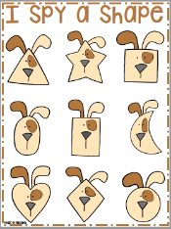  them in scattered &  linear configurations. | Cut a cereal box into different shapes. Children can put them together in different ways to make different things, or sort the shapes by how many sides they have.  [From Florida-Office of Early Learning]

Parent Resources: Other News: We are in need of food for snacks. If you haven’t brought a snack to share with our class, please consider bringing one this week. If you are able to donate a snack for the class, once a month, that is very helpful! Thank you!!

