Take a Peek at Our Week

Tiffany Green ~ Ones ~ Creating Our Community Week of September 6, 2021
Standards | Activities | Home Extension
IV Language and Literacy  A. LISTENING AND UNDERSTANDING  Responds to adults' request using gestures or simple words showing an understanding of what is being said.  II Approaches to Learning  B. PERSISTENCE  Pays attention for longer periods of time and persists at preferred activities  VIII. Creative Expression Through the Arts  Combines a variety of open-ended, process-oriented and diverse art materials to explore technique with intention | Signing back and forth to communicate with the children for wants/needs.  “Eat, drink”  Food and Nutrition- Practice Eating with Utensils  Self- Help:Using spoons and forks to feed oneself.  Fingerpainting and paper tearing  Read the 5th day of Creation.  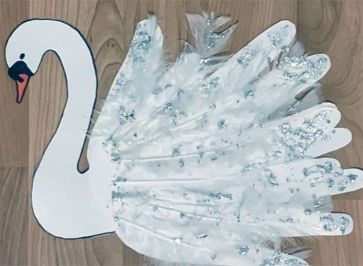 | Sending home another page of signs. 😊 This time we have new vocabulary to go with our previous signs.  Practice eating with utensils at home too. Rolls of visqueen plastic are great for placing down under tables and chairs for easy clean up 😉  On the 5th day of creation God made birds and fish. Explore a pet store together and enjoy the adventure, sharing with your child all of the different types of fish they have there.

