Take a Peek at Our Week

Tiffany Green ~ Ones ~ Creating Our Community Week of September 13, 2021
Standards | Activities | Home Extension
VII Social Studies  B. INDIVIDUAL DEVELOPMENT AND IDENTITY  Begins to recognize characteristics of self (eyes, nose and hair)  Faith Formation  Creation/ I am wonderfully made  VII. Social Studies  C. Individuals and groups.  Identifies family members. | Facial Response activity: Naming various facial expressions of others and self-incorporating mirrors and faces of characters in stories.  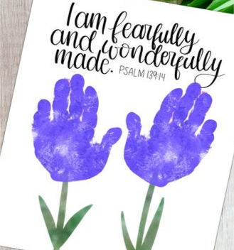 handprint craft  Looking at family photos(previously sent in by families) Make it into a game and see if child can find their family photo and place their own picture, with their family photo. | Practice making different expressions with your child and ask them to mirror your expressions.  Read Psalm 139:14 with your child “I am fearfully and wonderfully made”  Explore photo albums together and see if your child can identify themself as a baby. See if they recognize themselves.

