Take a Peek at Our Week
Tiffany Green ~ Ones ~ Creating Our Community Week of August 9, 2021
Standards | Activities | Home Extension
V Mathematical Thinking  C. PATTERNS  1. Matches objects that have a singular attribute (e.g., color, shape, size)  VI Scientific Inquiry  C. PHYSICAL SCIENCE  1. Demonstrates knowledge related to physical science  VII Social Studies  B. INDIVIDUAL DEVELOPMENT AND IDENTITY  1. Begins to recognize characteristics of self (eyes, nose and hair) | Use puzzles as manipulatives to help distinguish between colors, shapes and patterns.  We will be painting our day one of Creation projects. The sun and the moon paper plate crafts.  Studies show that between 18 and 24 months, many toddlers start to recognize themselves in a mirror and in photos.  We’ll be asking the children to point to different body parts (“touch your nose” and “show me your chin”), and give them a moment to find it on their own before showing them.  Singing “Head, shoulders, knees and toes”. | Let child sort through fruits and veggies with you at the grocery store and show them all of the different shapes and colors they come in.  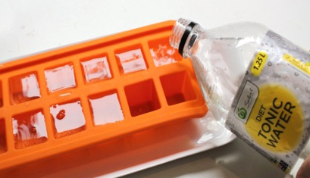  More specifically, you need tonic water that contains a small amount of quinine listed as one of the ingredients. Diet tonic water is less sticky. 😉 Freeze and enjoy the glow underneath a blacklight to simulate how the moon and stars do at night. (These are also edible)  Please bring in a photo of you and your child. A family photo is perfect! We will use it all throughout this unit to show the different characteristics each of us in our community have and how God made us each special and unique in our own way.

