Take a Peek at Our Week

Tiffany Green ~ Ones ~ Creating Our Community Week of August 23, 2021
Standards | Activities | Home Extension
VI Scientific Inquiry  C. PHYSICAL SCIENCE  Demonstrates knowledge related to physical science. Demonstrates ability to move objects  V Mathematical Thinking  C. PATTERNS  Matches objects that have a singular attribute (e.g., color, shape, size)  Explores two objects by making direct comparisons | Day three of Creation crafts. Tissue paper flower pots.  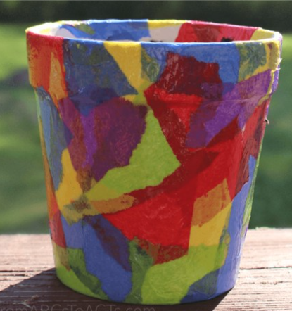  Using an empty ice tray and different colored pom poms to sort out by like colors, and then by different colors. Seeing if the child can find the pattern. We will also use different sizes of pom poms to see if they can sort by size as well as color. | Build plants out of building blocks.  Using an empty ice tray as well, and different colored pom poms, have your child continue practicing to arrange them into the ice tray by like colors, and by same size.

