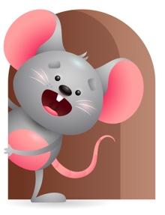
Peek at Our Week

Standard Focus | Activity | Home Extension Activity
Language and Literacy-Younger- Uses babbling consonant-like sounds. Older-Begins orienting to own name and enjoys playful word games like peek-a-boo. | Younger-Read the book Old McDonald had a farm and make the sounds of each animal-encourage them to repeat the sounds. Older- Read look at me I can clap and use the child’s name as you read-and play peek a-boo and say I see you and use (child’s name). | Younger- Read books to them and say the name of things you see and make sounds for them to repeat. Older-Do simple finger plays like where is Thumbkin? Put your child’s name in for Thumpkin. Sing and do other finger plays using their names.
Mathematical Thinking-Younger- Explores objects in hands. Older- Observes songs and finger plays that involve numbers and quantity. | Younger- We will stack cups and count to 3 while doing it. Put objects in their hands for them to explore. Older- Sing songs and do finger plays- 1,2,3,4,5, once I caught a fish alive- Five green and speckled frogs. | Younger- Give your child different and interesting toys that they can explore with their hands. Older- Do finger plays and sing songs that involve counting 1-5.
Social and Emotional-Younger- Shows recognition of familiar adults and imitates their facial expressions. Older- responds to a range of emotions. | Younger- Read smile pout pout fish and talk about the expressions in the book. Older- Read the character kids book and talk about words like cooperative and kind-tell them you are happy when they are kind-cooperative. | Younger- Read books on emotions or facial expressions and talk to them about what they are. (Smiling-Happy- Crying-Sad) and so on. Older- During the day say things like I like the way your lying still to change your diaper- your being cooperative-

Parent Resources

Other News-

