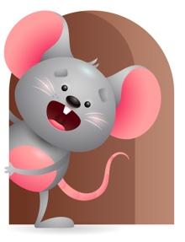
Peek at Our Week

Standard Focus | Activity | Home Extension Activity
Social Studies-Younger- Recognizes familiar people and objects. Older-Begins to respond to schedules. | Younger- Show them pictures of familiar people and tell them who it is. Let them play with the familiar objects they like (blocks- balls- pop up toy) Older- show pictures of schedules and ask do you know what it is time for? | Younger- Lay some toys out and play a game- where is the ball, car, block, book, as you pick it up say here is the ball, car, block, book, they will begin to recognize what it is called. Older- through the day let them know what it is time for- breakfast-lunch-supper-bath time-bedtime- play- get dressed-snack- nap- outside time.
Creative Expression- Younger- Uses movement to show body awareness. Older- responds to music in a variety of ways. | Younger- Sing God made the world and if I were a butterfly and do the body motions. Older- Sing this little light of mine and twinkle little star-see if they can do the motions with you. | Younger- Show them different ways they can move their bodies-clapping hands-bouncing- wiggling fingers and toes and dancing. Older- play some music and let them respond their way. Show them some things they can do to move.
Social Emotional-Younger- Demonstrates appropriate emotional response. Older- identifies and responds to a range of emotions. | Younger- Show what it looks like to be Happy-Sad- Mad-Angry- Older- Look in the mirror and make faces at each other. Smile and say this is Happy- Cry this is Sad- Mad is Angry. | Younger- Continue to make different facial expressions at them and tell them what it is. If you have a book on emotions, you could read it. Older- Continue to make faces in the mirror with them- through repetition they will begin to know what emotion it is.

Parent Resources

Other News-

