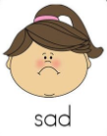
Peek at Our Week
Standard Focus | Activity | Home Extension Activity
IV. LANGUAGE AND LITERACY  F. EMERGENT READING  2. Shows age-appropriate phonological awareness  3. Shows alphabetic and print knowledge  IV. F. 3. a. Recognizes that print conveys meaning | Our letter this week is "Cc"  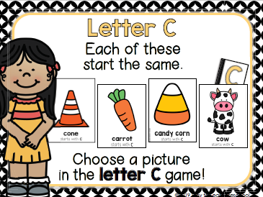 | Write the letters Aa, Bb, and Cc on separate pieces of paper. Look for a few items around your home that start with the short /a/ sound as in “apple,” the /b/ sound as in “banana”, and the hard /c/ sound as in “candle.” Have your child sort the items into either an “Aa,” “Bb,” or “Cc” group, according to their beginning sound.
FAITH FORMATION  Plays, works and prays happily with others.  Develops a sense of awe and wonder, respect, gratitude and stewardship for God’s creation.  VI. SCIENTIFIC INQUIRY  D. EARTH AND SPACE SCIENCE  VI. D. 1. b. Discovers, explores, sorts, compares and contrasts objects that are naturally found in the environment (e.g., rocks, leaves and sea shells)  VI. D. 1. c. Begins to explore and discuss simple observations of characteristics and movements of the clouds, sun, moon and stars  VI. D. 1. d. Compares the daytime and nighttime cycle | 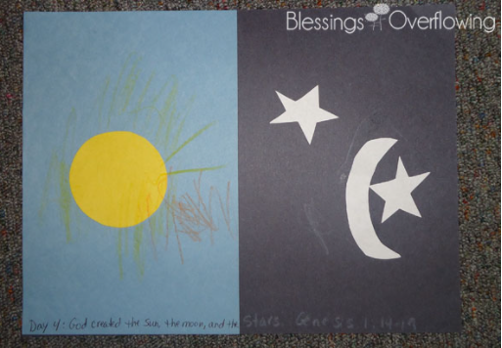  God created the sun, moon, and stars. Genesis 1:14-19  We will discuss the sun, moon, and stars:  -our sun is a star  -we see the sun during the day  -we can see other stars and the moon at night  -sometimes we can see the moon during the day also | Read, look at pictures, and discuss “Creation” in a children’s picture Bible.  If you walk outside in the evening this week, and there aren’t many clouds, talk about the stars in the sky with your child. Currently in the eastern sky just after sunset, you can also view the planets Jupiter and Saturn.  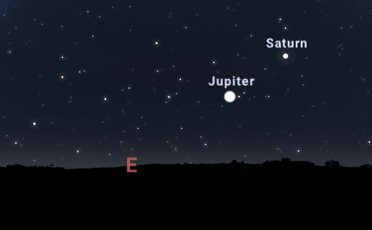

Standard Focus | Activity | Home Extension Activity
III. SOCIAL AND EMOTIONAL DEVELOPMENT  A. EMOTIONAL FUNCTIONING  1. Expresses, identifies and responds to a range of emotions  III. A. 1. a. Recognizes the emotions of peers and responds with empathy and compassion  B. MANAGING EMOTIONS  1. Demonstrates ability to self-regulate  III. B. 1. a. Recognizes and names own emotions and manages and exhibits behavioral control with or without adult support | 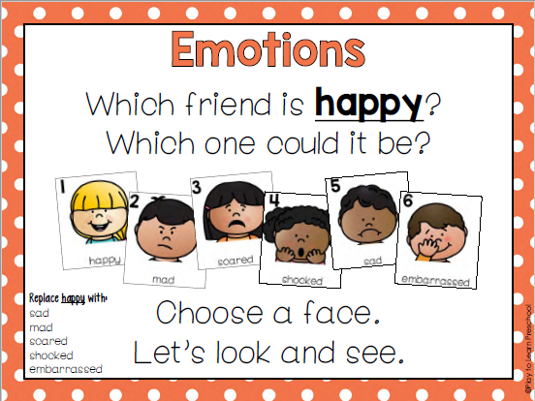  We will be learning about our Feelings/Emotions this week.  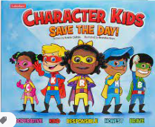 Character Kids SAVE THE DAY! [Emphasis on “Brave-Alex”] | Sung to the tune Hokey Pokey:  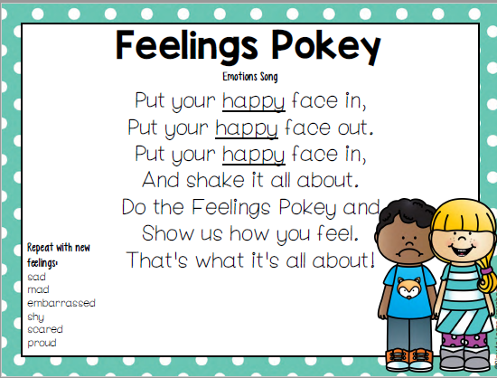
V. MATHEMATICAL THINKING  F. MEASUREMENT AND DATA  V. F. 2. Identifies measurable attributes | Sorting objects into groups in two different ways (size and color):  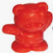  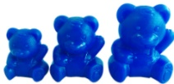 | Sort toys or other objects at home by an attribute such as size, color, type of toy, matching socks, dad’s clothes vs. child’s clothes, etc.

Parent Resources:

Other News:
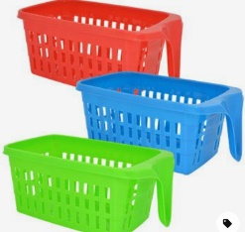
- The Office of Catholic Schools and Centers in Diocese of St. Petersburg, has told us that masks are to be worn inside by teachers and students age 4 years and older. This is in affect starting today until the positivity rate of COVID is below 10% in Pasco County.
- We are requesting parents to bring in a shoe box or shoe box size plastic container. We will be putting your child’s name and animal symbol on the box/container and use these on our cubby shelf. This will help us contain and separate the students’ water bottles, shoes, etc. I found these at the Dollar Tree in Dade City:

