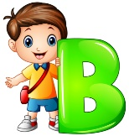
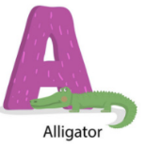
Peek at Our Week
Standard Focus | Activity | Home Extension Activity
IV. LANGUAGE AND LITERACY  G. EMERGENT WRITING  1. Begins to show motivation to engage in written expression and appropriate knowledge of forms and functions of written composition  IV. G. 1. a. Intentionally uses scribbles/writing to convey meaning (e.g., signing artwork, captioning, labeling, creating lists, making notes) | Our letter this week is "Bb"  In addition to learning about letters and their sound(s), we are talking about how to write the letter.  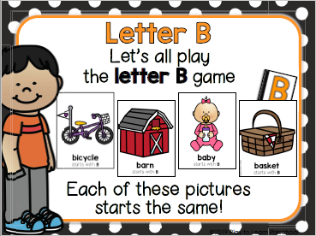 | Offer paper and something to write with (pencil, colored pencil, marker) to your child. In class I am looking at how the children are holding pencils and markers.  As you watch your child draw or write, notice if he/she is using a “whole hand” grip or a “three-point finger” grip. If she/he is using a “whole-hand” grip, gently move the fingers into a “three-point finger” grip.
FAITH FORMATION  Plays, works and prays happily with others.  Develops a sense of awe and wonder, respect, gratitude and stewardship for God’s creation.  VI. SCIENTIFIC INQUIRY  D. EARTH AND SPACE SCIENCE  VI. D. 1. b. Discovers, explores, sorts, compares and contrasts objects that are naturally found in the environment (e.g., rocks, leaves and sea shells)  B. LIFE SCIENCE  VI. B. 1. d. Begins to distinguish between living and non-living things | 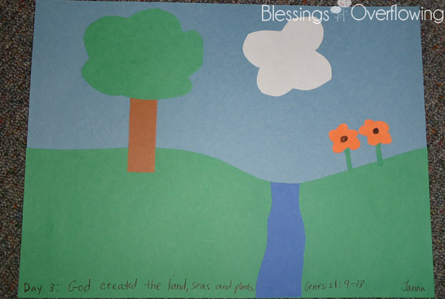  God created the land, seas, and plants.  Genesis 1: 9-11  We will also discuss what we can see on Earth’s land (rocks, sand, plants).  We will also sort pictures into the categories of “Living” vs. “Non-living.” | Read, look at pictures, and discuss “Creation” in a children’s Bible.  There are animated Bible Story videos available on YouTube. One example is “The Beginner’s Bible.”  https://www.youtube.com/watch?v=D9oh4YO8N7M  For the Creation Story Days 1 through 3, this is the part to view: 1:24 minutes to 4:08 minutes.  As you take or walk or go into your yard, you and your child may look for and discuss the rocks and plants you find. Which things are living and which are non-living?

Standard Focus | Activity | Home Extension Activity
I. PHYSICAL DEVELOPMENT  A. HEALTH AND WELLBEING  d. Feeding and Nutrition  I. A. d.1. b. Recognizes nutritious food choices and healthy eating habits | 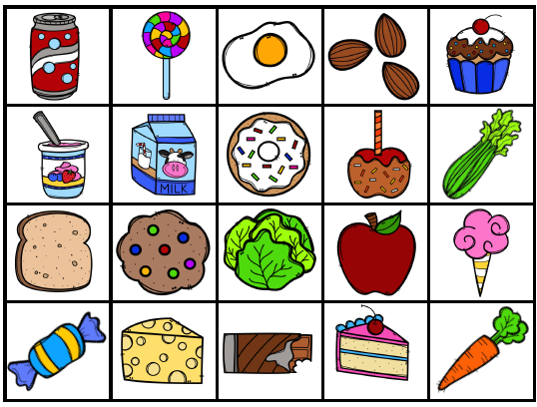  We will be sorting pretend food into categories of “Healthy/Growing Food” vs “Food that we eat for Treats Sometimes.” | Discuss which foods you eat throughout the week that are healthy “growing” foods, that are important to eat each day.

Parent Resources:
Our “Peek at Our Week” is also online at the Sacred Heart Early Childhood Center. This is where you can find it:
https://www.sacredheartecc.com/vpkb/

Other News:
- You may pack a snack for your child each day, or we can offer a snack that we have.
- If you would prefer your child to eat one of our snacks, we ask that each month you bring a snack that can be shared with the whole class. SHECC is a “peanut/tree nut free school,” so please check ingredient lists to make sure there are no peanuts or tree nuts on the list.

