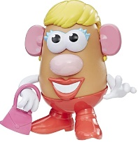
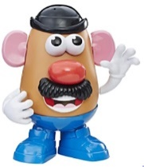
Peek at Our Week
Standard Focus | Activity | Home Extension Activity
IV. LANGUAGE AND LITERACY  F. EMERGENT READING  3. Shows alphabetic and print knowledge  IV. F. 3. a. Recognizes that print conveys meaning  A. LISTENING AND UNDERSTANDING  1. Demonstrates understanding when listening  IV. A. 1. a. Engages in multiple back-and-forth communicative interactions with adults | This week we will start with “Our Letter of the Week.” Our letter this week is “Aa.”  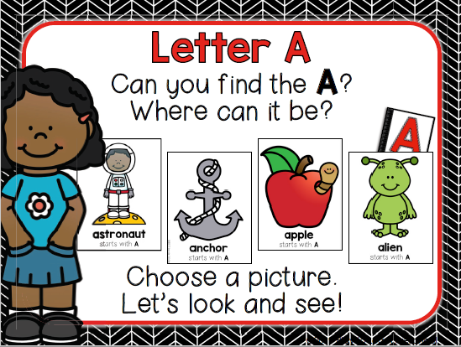  We also will be learning about parts of our bodies (head, arms, legs, neck, hand, etc.). | Singing the ABCs is always a good practice at this age. Slowing down when you get to the letters  “L, M, N, O, P” helps children hear each letter separately. Also, pointing to the letters as you sing is helpful. Does your child have a letter “Aa” in her or his name? If so, you may point out the letter and make a connection to the ABC song.  You may play a brief game of “Simon Says” with your child to reinforce the names of our body parts. (e.g., “Simon says touch your elbow”).
FAITH FORMATION  Plays, works, and prays happily with others.  Develops a sense of awe and wonder, respect, gratitude and stewardship for God’s creation. | CREATION- On the second day God separated the water from the sky (Genesis 1:6-8).  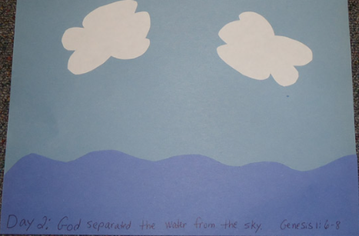 | Here is a Creation Song you may sing at home.  (Sung to the tune of Frere Jacques)  God created! God created!  Night and day, night and day.  That was on the first day.  That was on the first day.  And it was good! It was good!  God created! God created!  Sky and clouds, sky and clouds.  That was on the second day.  That was on the second day.  And it was good! It was good.
V. MATHEMATICAL THINKING  V. C. 1. Identifies and extends a simple AB repeating pattern | ABAB Pattern Practice | 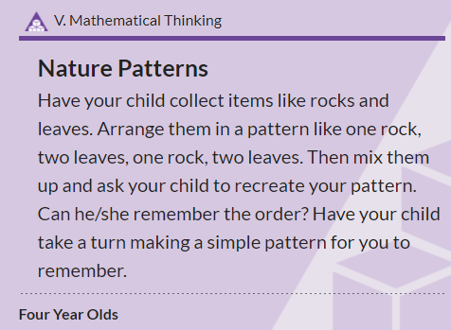
SAFE ENVIRONMENT STANDARDS  SECD: 1d There are “good” and “bad” choices | Character Trait Focus: Kindness  The character from our book, that represents kindness is named Scooter.  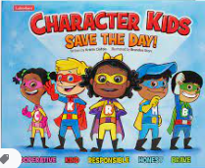 | Here at Sacred Heart Early Childcare Center, we use the Character Kids Save the Day book to help teach good character traits. The story gives two examples of how Scooter is being kind. One example shows Scooter holding a door open for a friend who has a leg cast and is using crutches. The second example shows Scooter including a friend in play who was crying and feeling left out.  If your child sees a positive or upsetting situation between two people (e.g., at a store, at school, on TV), you may use this opportunity to discuss how each person did or did not act in a “kind way.”

Parent Resources:
Other News:
>Starting today, please drop-off and pick-up your child at our classroom door.
>Our daily schedule has changed. We now are going outside soon after the children arrive. The outside temperature is a bit more comfortable at 9:15 a.m. than at 11:00 a.m.
>We are working on having everyone in socks or Crocks shoes while inside and wearing tennis shoes when we go outside.
> If possible, please have your child bring a drink in a water bottle (labeled with their first and last name) to school each day.

