Peek at Our Week
Standard Focus | Activity | Home Extension Activity
III. SOCIAL AND  EMOTIONAL DEVELOPMENT  D. SENSE OF IDENTITY AND BELONGING  1. Develops sense of identity and belonging through play  III. D. 1. a. Engages in associative play and begins to play cooperatively with friends  IV. LANGUAGE AND LITERACY  G. EMERGENT WRITING  1. Begins to show motivation to engage in written expression and appropriate knowledge of forms and functions of written composition  IV. G. 1. a. Intentionally uses scribbles/writing to convey meaning | Learning the names of others in class.  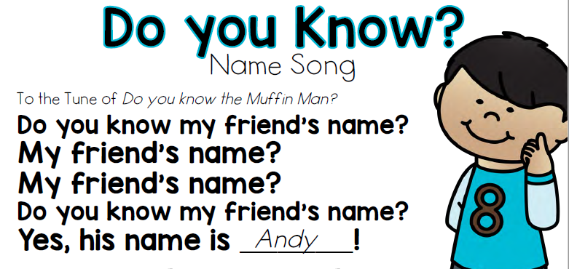  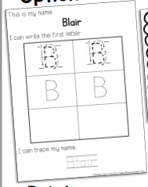  Learning/reviewing the first letter of our name and practice writing the upper-case letter. | Ask your child about the friends they have met at school.  “What are their names?”  “What do you like to play together?”  Talk about what letters are in your child’s first name. Have your child practice writing the first letter in their name. You may use a yellow marker to write the upper-case letter, so that your child may trace it before practicing on their own. If your child is ready for the other letters in their first name, continue with lower-case letters.
FAITH FORMATION  Plays, works and prays happily with others.  Develops a sense of awe and wonder, respect, gratitude and stewardship for God’s creation. | CREATION-In the Beginning there was Nothing but God. Day 1-God said, “Let there be Light.” Genesis 1:3  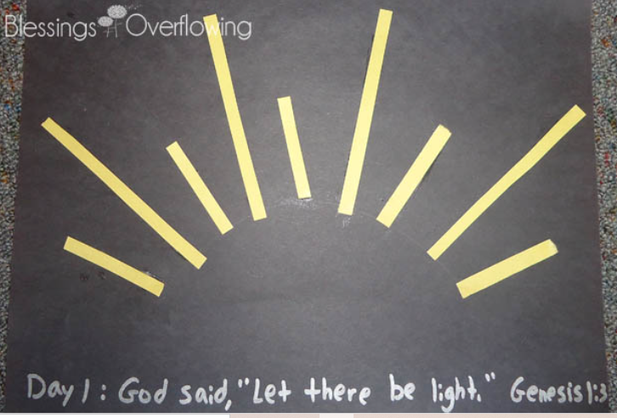  We begin our book about God’s Creation. | Caring for God's Creation  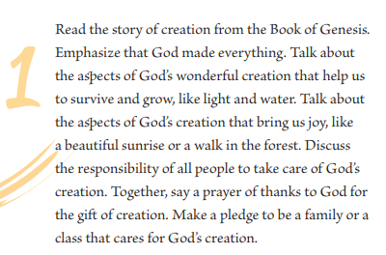  Taken from:  https://go.sadlier.com/religion/caring-for-gods-creation-ebook

Standard Focus | Activity | Home Extension Activity
V. MATHEMATICAL THINKING  V. A. 2. Counts and identifies the number sequence “1 to 10.” | 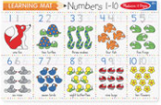  Each Day we will be counting verbally in the classroom. We will start with 0-10 and by the end of the year we will be counting to at least 30. | 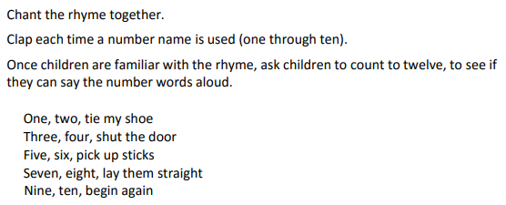  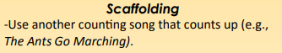

Parent Resources:
The Florida VPK Standards can be viewed at this website:
http://www.floel.org/standardsresource/standards.html#d=I,II,III,IV,V,VI,VII,VIII&a=four_year_olds

Other News: WELCOME !
>Inside the classroom, the children may wear socks or Crocs shoes. Please also wear a pair of tennis shoes for when we go outside to play (and also to leave).
>If possible, please have your child bring a water bottle (labeled with their first and last name) to school each day.
*Thank you for all the school supplies!!

