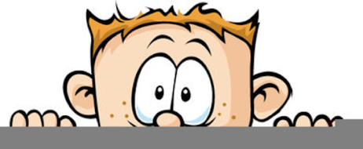

Peek at Our Week
Florida Early Learning and Development Standards | School Activity | Home Extension Activity
Scientific Inquiry  - Begins to explore materials and construct simple objects and structures and begins to explore motion and stability | 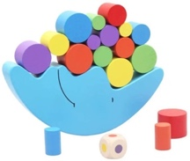  Balance/Stacking Puzzles:  In our classroom, we have a variety of these types of puzzles and games. They require persistence, the ability to learn from experience, planning, and imagination. | If you have paper or plastic cups, have your child see how many they can stack. Pick a random selection of toys and then see if you can balance them on top of each other.
Social Studies  - Begins to follow routines (e.g., family, classroom, school and community) | Sorting food into groups of “Growing foods” and “Snack foods”  When playing in the Kitchen Center, the children will sort the foods. Also, when getting out their items for lunch, they will learn to identify what category different food are in. | Talk to your child about healthy foods and encourage healthy choices. Have your child cut out healthy food from the grocery ads and glue them to a piece of paper to display in your kitchen.
Physical Development  - Carries out some steps of own personal hygiene routines with specific adult guidance or demonstration | Finger painting and practicing thorough handwashing  The children will finger paint and then they will wash their own hands until all the paint is gone. | Intentionally plan a cooking project where your child will get their hands messy helping. Then give them time to completely wash their hands. At school we make bubble gloves with the soap and water before putting our hands under the water to rinse.
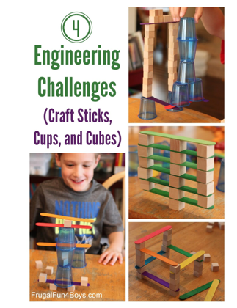
Parent Resources: Check out Frugal Fun for Boys and Girls website for balancing and stacking activities using very small plastic cups, one-inch cubes and wide craft sticks.
I have attached a copy of our handwashing song to hang by your sink at home.

