Peek at Our Week
Florida Early Learning and Developmental Standards | School Activity | Home Extension Activity
Religious Focus: Creation – Day Seven  - “All He had made was very good and He rested | 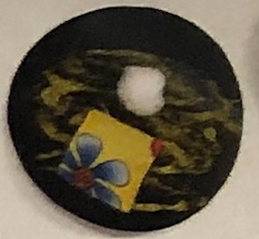  This is an example of what God’s bed might look like | Intentionally schedule some time to relax and rest as a family this week. Explain to your child that resting is important.
Mathematical Thinking  - Begins to demonstrate an understanding of basic spatial directions through songs, finger plays and games  Language and Literacy  - Demonstrates understanding when listening | Practice positional words using a prop on the floor  Hula hoops, Blankets, Large blocks will be set out on the floor. Children will follow direction which utilize positional words such as, “Stand on the block”, “Stand in the hula hoop”, “Stand next to the blue blanket.” | This game can be played inside or outside using objects you have at home. Practicing positional words in this manner helps your child when it comes to lining up or sitting at circle.
Social Studies  - Begins to sequence events | Days of Creation Game  The children will be given cards which depict the six days of creation and one day of rest. They will be asked to put them in order. | To celebrate learning about Creation, you could watch the first half of The Beginner's Bible Curriculum - Lesson 1

