Peek at Our Week
Florida Early Learning and Developmental Standards | School Activity | Home Extension Activity
Religious Focus: Creation – Day Five  - “Let there be creatures in the sky and sea.” | 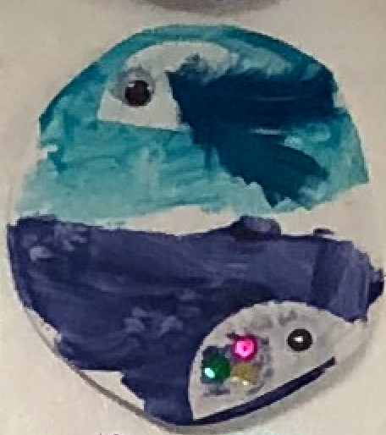  This is an example of what the children will be creating. . | Take a virtual field trip to an aquarium or aviary.  The Shedd Aquarium website is fun to explore.
Language and Literacy  - Uses verbal and nonverbal communication and language to express needs and feelings, share experiences and resolve problems | Reading Others Game:  Give each child a mirror and ask them to make faces depicting different emotions | At home, you can make a face in the mirror and ask your child, “What am I feeling?” Explore lots of different emotions such as frustration, embarrassment, or worry. Talk about how your body feels when you are angry. For example, your heart might pound in your chest, your face might feel hot, or your hands are in a fist. Recognizing these bodily reactions to an emotional can help a child to be able to identify that feeling and learn to calm down those sensations.
Language and Literacy  - Uses verbal and nonverbal communication and language to express needs and feelings, share experiences and resolve problems  - Engages in conversations using words, signs, two- or three-word phrases, or simple sentences to initiate, continue or extend conversations with others | Character Kids Game  Match all the different Character Kid pictures and talk about their attributes. | The Character Kids are the center of our Social/Emotional Learning curriculum. Scooter is kind. Brandy is cooperative. Keisha is responsible. Ricky is honest. Alex is brave. Using this vocabulary at home will be helpful in your child learning these character traits. For example, when your child cleans up their toys when first asked, say “You are being so cooperative.” If your child gets frustrated when trying to build say, “Don’t get frustrated. Take a deep breath and get brave.”
Parent Resources: There is a video of me reading the Character Kids Save the Day book on our website under the Classes Tab. If you are interested, here is the link to purchase a copy of the Character Kids Save the Day Book.

