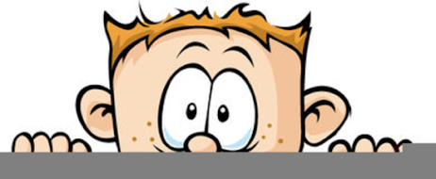

Peek at Our Week
Florida Early Learning and  Developmental Standards | School Activity | Home Extension Activity
Religious Focus: Creation – Day Three  - “Let there be dry land and plants.” | 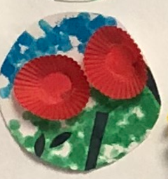  This is an example of what the children will be making to represent the creation of land and plants. | Children enjoy taking care of things, so now might be a good time to plant some flowers in a pot for your child to water and take care of.
Language and Literacy  - Demonstrates understanding when listening  - Engages in multiple back-and-forth communicative interactions with adults and peers during creative play and in purposeful and novel situations | Listening Game:  Finish my line  Ask the child to finish your sentences. You can use popular children’s songs, poems, or everyday phrases, e.g., “Twinkle, twinkle little…” | This Listening Game can be easily played at home with your favorite songs, repetitive books and phrases.
- Language and Literacy  - Demonstrates understanding when listening  - Social Studies  - Begins to recognize expectations in varying settings | Voice Modulation Game  Sing “I have a Soft Voice” song first using a normal tone of voice, then sing it loudly, then as a whisper, and finally using a normal soft voice again. | Play the Voice Modulation Game at home with a song you know such as Twinkle, Twinkle Little Star. Remember the goal is to teach your child how to use a soft or normal tone of voice and how to change their tone when asked to use a soft voice or a whisper or to be completely quiet.
Parent Resources: Here is a link to a video which teaches what a plant needs to grow, entitled
Needs of a Plant - Early Learning | Preschool Song For Kids

Arrival, Snack & Morning Activities  (All children potty and wash hands when they arrive) | 6:30–8:45
Circle Time | 8:45-9:00
Center Time  (All children will potty and wash hands during this time) | 9:00–10:30
Circle Time | 10:30–10:45
Lunch time  (All children wash hands before going outside) | 10:45-11:15
Outside | 11:15–12:00
Calm Down Time: Video book or song,  (All children potty and wash hands & face before nap) | 12:00-12:15
Nap  (All children potty and wash hands after nap) | 12:15-2:30
Flex Time  Centers, Small Group Activity or Circle time depending on the length of nap | 2:30-3:00
Outside | 3:00-3:45
Snack  (All children will wash hands before snack & potty and wash hands after snack) | 3:45-4:15
Center Time | 4:15–5:00
Manipulatives | 5:00-5:30

